**VIETNAM NATIONAL UNIVERSITY – HO CHI MINH CITY THE INTERNATIONAL UNIVERSITY SCHOOL OF COMPUTER SCIENCE AND ENGINEERING**



Thesis report

**Advisor: Dr. Tran Thanh Tung**

**Student name: Do Hung Cuong**

**Student ID: ITITIU13170**

**ABSTRACT**

Hotel business is a highly profitable industry but requires huge investment as well as having to meet the customer's demand. So how will your hotel be if one day the number of customers visit your hotel significantly reduce? And how do you know why it happens to your hotel?

You will never know why because you don’t have any ability to know the customer’s feeling. Therefore, one of my solution is to implment a Hotel Booking system which supports all hotel bussiness features with potential to track user’s behavior. Based on that, I can know what customer had done on my websites. I can see which pages customers clicked on, how long customers stayed at each page, which rooms, which services that customers had searched, booked, ordered or send the feedback. So far I can improve my hotel system to to catch up the wishes of customers

Because the customers will use a website to interact with my hotel. So that I have to make my system powerful. My very first plan is to experiment successfully some popular, modern technologies such as Single Page application, Microservice, MEAN, and Spring MVC to implement my Hotel Booking & Reservation System with more than 120 features for both customers and administrator.

**List of Tables**

Table 1: Terms and Descriptions

Table 2: RESTful webservice HTTP methods

Table 3: List of features

**List of Figures**

Figure 1 – 2: the customers made a queue and wait for another booking at hotel.

Figure 3 – 4: Some old hotel booking systems look very bad.

Figure 5: Marriott International Hotel Booking System.

Figure 6: Single Page Appiication lifecycle.

Figure 7: AngularJS by Google.

Figure 8: Angular 2 with TypeScript.

Figure 9: RESTful Webservice.

Figure 10: Node.js and Express framework.

Figure 11: Java and Spring framework.

Figure 12: SQL and Hibernate framework.

Figure 13: NoSQL and mongoDB.

Figure 14: MEAN stack technology.

Figure 15: MVC pattern.

Figure 16: Spring MVC framework architecture

Figure 17: Spring MVC with Three Layer architecture

Figure 18: Hibernate architecture

Figure 19: Angular architecture

Figure 20: RESTful webservice architecture

Figure 21: Express MVC architecture

Figure 22: MEAN stack technology architecture

Figure 23: Benefits of Microservice

Figure 24: Use Case Diagram

Figure 25: Nodejs and Express MVC framework system architecture

Figure 26: Spring MVC Hibernate system architecture

Figure 27: Nodejs and Express framework RESTful webservice system architecture

Figure 28: Spring Hibernate RESTful webservice system architecture

Figure 29: Spring Hibernate RESTful webservice interacts other REST API system architecture

Figure 30: AngularJS system architecture

Figure 31: Angular 2 system architecture

Figure 32: Official system architecture

Figure 33: MongoDB collections

Figure 34: SQL Entity Relationship diagram

Figure 35: MongoDB collections and SQL Entity Relationship diagram

Figure 36: Spring Controller class diagram

Figure 37: Spring Bean and Pojo class diagram

Figure 38: Spring Hibernate DAO class diagram

Figure 39: Spring API DAO class diagram

Figure 40: Spring Service class diagram

Figure 41: Spring REST Controller class diagram

Figure 42: Spring App Controller class diagram

Figure 43: Spring JSP class diagram

Figure 44: Spring Front Controller

Figure 45: Spring Helper class diagram

Figure 46: Offical Spring class diagram

Figure 47: Express Model class diagram

Figure 48: Express Controller class diagram

Figure 49: Express App Route and EJS class diagram

Figure 50: Offical Express class diagram

Figure 51: Customer login feature

Figure 52: Customer register feature

Figure 53: Manage Customer feature

Figure 54: Send Contact Feature

Figure 55: Send Reservation Form feature

Figure 56: Send Feedback feature

Figure 57: Review Activity feature

Figure 58: Manage Customer’s Activity feature

Figure 59: Reply Email feature

Figure 60: Rcomemdation Room feature

Figure 61: View tracking data feature

Figure 62: View tracking data feature by username

Figure 63: View tracking data feature by ip address

Figure 64-65: Geo Location Lockup Feature

Figure 66: View Pie chart by Country and visit time Feature

Figure 67: View Colunm chart by Page Access and visit time Feature

Figure 68: Add new Room Feature

Figure 69: Update Room Feature

Figure 70: Remove Room Feature

Figure 71: View All Rooms Feature

Figure 72: View Single Room with Related Room Feature

Figure 73: View Single Restaurant Item Feature

Figure 74: Customer view Rooms

Figure 75: Customer view Hotel Restaurant

Figure 76: Customer book room feature

Figure 77: Customer cancel room feature

Figure 78: Customer feedback room feature

Figure 79: Admin profile feature

Figure 80: Advance search feature

Figure 81: Experiment on Firefox

Figure 82: Experiment on Microsoft Edge

Figure 83: Experiment on Internet Explorer

Figure 84: Experiment on laptop with Chome

Figure 85: Experiment on Iphone 8 plus

Figure 86: Experiment on Iphone 8 iPad

**Terms and Definitions**

|  |  |
| --- | --- |
| Term | Descriptions |
| Guest | User doesn't have an account who can use some  unnecessary-login features |
| Customer | User has an account who can login to use some additional features |
| Administrator | User who can manage the system includes users, hotel items, request of customers and statistics. |
| HTML | Hypertext Markup Language, is used for browsers to render the content of the web page |
| CSS | Cascading Style Sheets, is uesd to decorate the elements of HTML |
| Javascript | JavaScript is the programming language of HTML and the Web allows you to implement complex things on web pages. Nowadays, Javascript can also run on server side thank to Node.js (see more in section 1.3.4) |
| jQuery | jQuery is open source Javascript library that supports the shorter syntax for Javascript coding that makes JavaScript easier to use for website developer. |
| Boostrap | Open source front-end framework includes HTML, CSS, Javascript, Jqeury, Image, Icon which are used to design templates and support ability to easily create responsive designs. |
| EJS | Effective JavaScript templating, is simply used as a templating language which supports rendering HTML markup with plain JavaScript. |
| JSP | Java Server Page, is used as a technology for building the content of a web page using the Java programming language |

Table 1: Terms and Descriptions

**Table of Contents**

**Chapter I.****INTRODUCTION****1**

1.1/ Situation 1

1.2/ Modern Hotel Booking System 1

1.3/ Technology 2

1.3.1/ Single Page Application 2

1.3.2/ Angular 2

1.3.2.1/ Angular 1- AngularJS 2

1.3.2.2/ Angular 2 2

1.3.3/ RESTful webservice 2

1.3.4/ Nodejs & Express framework 2

1.3.5/ Java & Spring framework 2

1.3.6/ SQL & Hibernate: 2

1.3.7/ MongoDB 2

1.3.8/ MEAN stack 2

1.4/ Goals and Scope 2

**Chapter II. BACKGROUND****1**

2.1/ Model - View - Controller 1

2.2/ Spring MVC 1

2.3/ Hibernate 2

2.4/ Angular 1

2.5/ RESTful webservice 1

2.6/ Express framework and Nodejs 2

2.7/ MEAN stack technology 2

**Chapter III. SOFTWARE REQUIREMENT** **1**

3.1/ System Overview 1

3.2/ Feature 1

3.2.1/ Guests 2

3.2.2/ Customer 2

3.2.3/ Administrator 2

3.3/ Use Case 2

3.4/ User Story 1

**Chapter IV.****IMPLEMENTATION****1**

4.1/ All Technology used 1

4.2/ System Architecture 1

4.2.1/ MVC architecture 2

4.2.2/ Spring MVC Hibernate 2

4.2.3/ RESTful Webservice architecture 2

4.2.4/ Spring Hibernate RESTful webservice 2

4.2.5/ Spring RESTful webservice interact other RESTful webservice 2

4.2.6/ Angular on client side architecture 2

4.2.6.1/ AngularJS architecture 2

4.2.6.2/ Angular 2 architecture 2

4.2.7/ Full system architecture 2

4.3/ Database system 2

4.3.1/ MongoDB collection & document 2

4.3.2 / SQL ERD (Entity Realationship Diagram) 2

4.3.3/ MongoDB interact with SQL ERD 2

4.4/ Class diaram 2

4.4.1/ Model 2

4.4.1.1–Relationship Model 2

4.4.1.2/ Bean and POJO classes 2

4.4.2/ DAO 2

4.4.2.1/ Hibernate DAO 2

4.4.2.2/ API DAO 2

4.4.3/ Service 2

4.4.4/ Controller 2

4.4.4.1/ REST Controller 2

4.4.4.2/ App Controller, Front Controller and JSP 2

4.4.5/ CONST and Helper classes 2

4.4.5.1/ CONST Classes 2

4.4.5.2/ Helper Classes 2

4.4.6/ Offical Spring Class Diagram 2

4.4.7/ Model-JS 2

4.4.8/ Controller-JS 2

4.4.9/ Route-JS 2

4.4.9.1/ AppRoute with EJS 2

4.4.9.2/ APIRoute 2

4.4.10/ Offical Express class diagram 2

4.5/ Implementation

4.5.1/ Customer feature 2

4.5.2/ Activity feature 2

4.5.3/ Tracking User feature 2

4.5.4/ Room feature 2

4.5.5/ Admin feature 2

4.5.6/ Other highlight feature 2

**Chapter V.** **Experiment and Evaluation 1**

1/ Experiments 1

2/ Evaluation 1

**Chapter VI.****CONCLUSIONS** **1**

**Chapter VII.****REFERENCES** **1**

**Chapter I.** **INTRODUCTION**

***1.1/ Situation***

Many years ago, in hotel business, the guest who really wanted to book a room had to come directly to the hotel and the reservation process had to be done before booking the desired room completely. In fact, if the huge number of guests came to hotel for booking at the same time, this hotel would be crowded. Then the customers had to wait for another booking, made a queue and wait for own turn. It wastes a lot of time and is very uncomfortable.

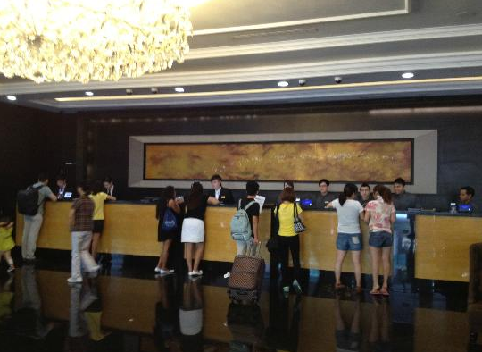

Figure 1 – 2: the customers made a queue and wait for another booking at hotel.

Moreover, in many enormous hotels, management was very difficult and booking based on pen and paper was not convenient for both the customers and the receptionists. Besides, the reservations might cause a lot of risk such as invalid information of customers, wrong information of rooms and booking.

Therefore, many applications had been released with lots of features to support hotel booking. However, at that time, performance of these systems might be very bad. They could overload or run extremely slow when a huge number of users was accessing at the same time. Moreover, the look and feed of these software user interfaces might not be designed beautifully. It leads to situation that many customers or even the administrators who manage the system were not pleased to use those systems.

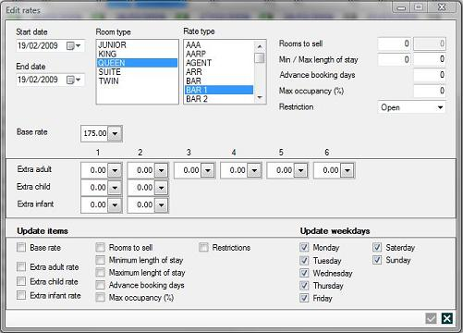

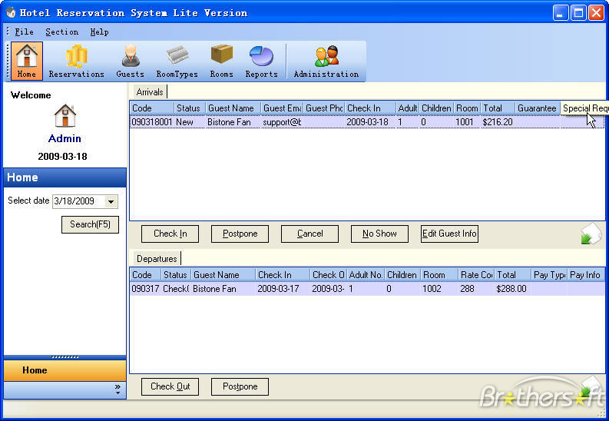

Figure 3 – 4: Some old hotel booking systems look very bad.

You can refre the link below for more information

<https://www.planet-source-code.com/vb/scripts/ShowCode.asp?lngWId=10&txtCodeId=7186>

<http://www.bistonesoft.com/litereservationstatus.htm>

***1.2/ Modern Hotel Booking System***

To solve these problems above, many deluxe hotels or five-stars hotels in the world such as Marriott International, Hilton Worldwide or InterContinental Hotels Group already have their own hotel booking systems.

In developing technology industry, their systems were improved so much with friendly user interface, high performance and especially the ability to track the behavior of customers. With this tracking customers feature, the administrators, the managers or hotel owners could know what customer had done on their websites. They would know which pages customers clicked on, how long customers stayed at each page, which rooms, which services that customers had searched, booked, ordered or send the feedbacks.

Based on the data collection, the systems will automatically suggest what customers may like, recommend which rooms customers should book. Moreover, the hotel owners can improve their hotel business based on the information collected by their systems.

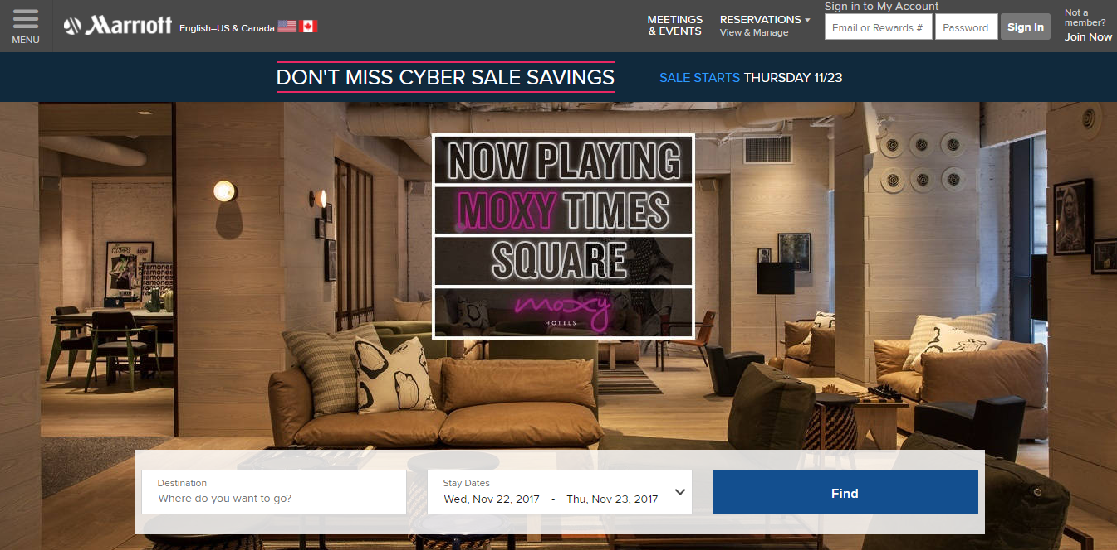

Figure 5: Marriott International Hotel Booking System.

***1.3/ Technology***

Nowadays, there are many technologies for building a hotel booking system based on web application. Today, one of the most popular architecture is Single Page Application.

1.3.1/ Single Page Application

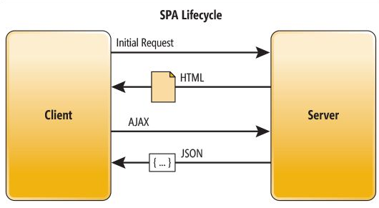

Figure 6: Single Page Appiication lifecycle.

Single Page Application is a web application that on only one single web page or only one index page contains dynamic actions which we do not need to refresh the page. Single Page Application interactions can be handle without reaching server.

Single Page Application can improve performance in many cases such as loading time, using AJAX, easy to navigate pages etc.

AJAX is a dream of developer, because the folowing reason:

* It supports changing the content of a web page without reloading it.
* After the page has loaded, we can still send request or receive data from the server
* In the background, we can also send data to a server

That is the reason makes the end users feel more comfortable when using Single Page Application.

Recently, many frameworks, platforms or techniques were released to support building a Single Page Application. Angular is one of the most popular Single Page Application framework.

1.3.2/ Angular:

Over the last 4 years, Angular has turned into the main open source JavaScript application framework. A huge number of developers all over the world begin to learn Angular and the Angular version 1.x has been widely used and became well known for website developers to build the complex applications. Then, Angular 2.x has been released to improve and overcome the weaknesses of its previous version.

1.3.2.1/ Angular 1- AngularJS:

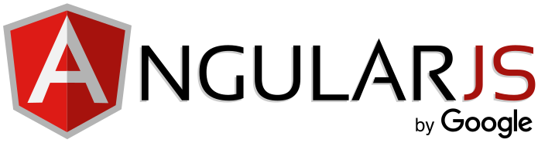

Figure 7: AngularJS by Google.

Recently, many frameworks, platforms or techniques were released to support building a Single Page Application. Angular is one of the most popular Single Page Application framework. It allows us to build a single page application easily because of the following reason:

* Angular makes the HTML more expressive by support some features such as if-else condition, switch-case, loop and local variable.
* Angular has powerful data binding. Thank to data binding, we can easily display variables from the data model such as component, track changes, and process updates from the user.
* Angular promotes modularity by design. Every Angular application is a set of building blocks and that is easier to create and reuse content.

- Angular has built-in support for communication with a back-end service. In Angular application, it is easy for the front-end to integrate with a backend server to get and post data or execute server-side business logic.

With so many developers already using Angular 1 or AngularJS, why do we need Angular 2?

1.3.2.2/ Angular 2:

* Angular 2 is faster than Angular 1. Angular 2 is built for speed so that the initial loads is faster, the change detection and improved rendering times are also faster than Angular 1.
* The fewer concepts of Angular 2 make it easier to understand than Angular 1. The code structure is very simplified than the previous version of Angular. Therefore, it is easier for the developer to learn and use Angular 2.
* In Angular 2, we can use Typescript which is a super set of Javascript. Typescript is a form of JavaScript, in Typescript we can know types and classes. Typescript can be compiled to JavaScript. TypeScript is an open source that contains many aspects of object orientation such as interfaces and inheritance. The TypeScript’s syntax is cleaner than Javascript and similar to C# or java. Because of using TypeScript, so we can use all its libraries and the functionality of TypeScript itself in Angular 2.

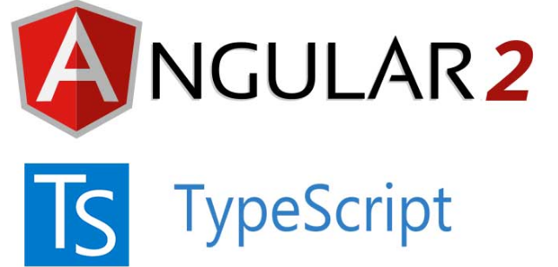

Figure 8: Angular 2 with TypeScript.

Angular 2 is mainly focused on mobile apps. Angular 1.x was not built with mobile support in mind, where Angular 2 is mobile oriented.

Angular is simply a front-end framework for building applications. It is not the right determinant for what backend you should use for your application.

1.3.3/ RESTful webservice:

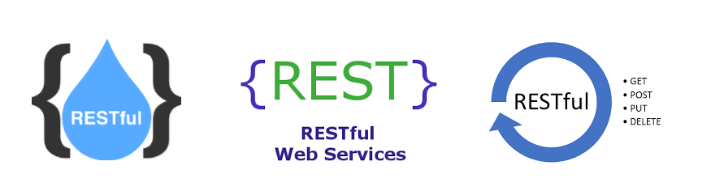

Figure 9: RESTful Webservice.

There are many ways to connect Angular to backend server. RESTful Web Service which is essentially REST Architecture based Web Services is one of the architectural style that helps Angular and backend server communicate with each other.

In REST Architecture, everything is a resource. RESTful web services are light-weight services so the developers usually use RESTful web services to make APIs for web-based applications.

In some case, RESTful Web Service help us write a software application in various programming languages and we can run them on various platforms. For example, we can write a backend server in Java using RESTful web service and connect to Angular on client side by HTTP method.

REST is a web standard based architecture which was first presented by Roy Fielding in 2000. The word ‘REST’ means Representational State Transfer. REST uses HTTP Protocol for data communication. It spins around resources where each component is a resource and a resource accessed by a typical interface utilizing HTTP standard methods.

RESTful Web Services are Web services based on REST Architecture. They use HTTP methods to implement the concept of REST architecture. URI is usually a service which a RESTful Web Service provides resource such as Text, JSON and XML.

There are many frameworks written in many programming language support build a RESTful webservice such as Nodejs REST API or Spring REST API for java.

1.3.4/ Nodejs & Express framework

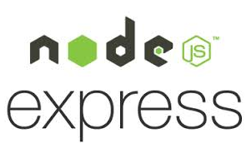

Figure 10: Node.js and Express framework.

Node.js is a JavaScript runtime based on Chrome's V8 JavaScript engine. Node.js utilizes an non-blocking I/O, event driven which makes it lightweight and productive

The package npm of Node.js is the biggest of open source libraries on the planet. Node.js application is written in Javascript so it is very easy to interact with Angular to build a Single page application easily

Express is a minimal and flexible web application framework for Node.js. The advantage of Nodejs combine with Express framework is listed below:

* APIs

With many HTTP useful, it is very quick and easy to create a powerful API especially RESTful webservice with API as JSON-like format

* Performance

An Express application always has higher performance than a lot of other frameworks for another language.Nodejs is built to be a real-time language which means the average handle speed is very fast and it is calculated by millisecond.

1.3.5/ Java & Spring framework 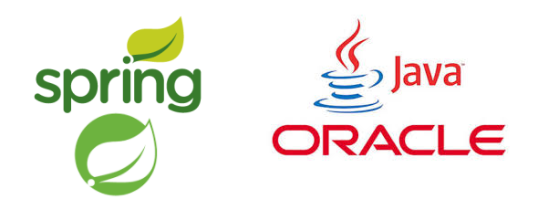

Figure 11: Java and Spring framework.

Java is a cross-platform programming language, it is one of the most popular programming language which powerfully supports OOP (Object-oriented programming). Object-oriented programming is programming language model, the reason it called “Object-oriented” is that it focuses on organization around objects rather than function and data rather than logic.

Spring MVC is the most powerful J2EE (Java Platform, Enterprise Edition) framework to build Java web application. It is an open source Java platform that provides comprehensive infrastructure support for developing robust Java based Web applications very easily and very rapidly.

Spring MVC provides a model-view-controller architecture and ready components that can be used to develop flexible and loosely coupled web applications. The MVC pattern results in separating the different aspects of the application (input logic, business logic, and UI logic), while providing a loose coupling between these elements.

We can also build a Spring RESTful webservice with some supported library such as jackson and gson.

1.3.6/ SQL & Hibernate:



Figure 12: SQL and Hibernate framework.

SQL is a standard language for storing, manipulating and retrieving data in databases. Some kind of SQL: MySQL, SQL Server, MS Access, Oracle, Sybase, Informix, Postgres, and other database systems.

Hibernate ORM (Hibernate in short) is an object-relational mapping tool for the Java programming language. It provides a framework for mapping an object-oriented domain model to a relational database. Hibernate handles object-relational impedance mismatch problems by replacing direct, persistent database accesses with high-level object handling functions.

Hibernate's primary feature is mapping from Java classes to database tables, and mapping from Java data types to SQL data types. Hibernate also provides data query and retrieval facilities. It generates SQL calls and relieves the developer from the manual handling and object conversion of the result set.

1.3.7/ MongoDB



Figure 13: NoSQL and mongoDB.

MongoDB, an open-source database, is one kind of NoSQL database system.because the entity relationship is not mandatory. In MongoDB, we have a mechanism for retrieval of data or storage in JSON-like documents that can vary in structure. Therefore, we can store related information together and with MongoDB query language, we can execute faster than SQL database system.

In MongoDB, we use dynamic schemas so we can create records without first defining the structure. We can also simply add delete fields or add new fields to change the structure of records (documents)

MongoDB is availability and scalability; it supports ability to store a lot of complex structures such as objects, arrays easily.

1.3.8/ MEAN stack

To build a Web Application we need at least one type of database system to store all the data. For example, to build hotel booking system, we need to store the information and so on for the servers to retrieve and display on the client user interface or to update the data which users saved to the database. MongoDB stores data in JSON-like documents so that it is a good type of database system to combine with Nodejs Express framework and Angular to build the best Single page application. It called MEAN stack technology which means MongoDB, Express, Angular and Nodejs.

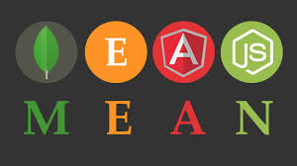

Figure 14: MEAN stack technology.

MEAN is a user-friendly full-stack JavaScript framework ideal for building dynamic websites and applications. It is a free and open-source stack designed to supply developers with a quick and organized method for creating rapid prototypes of MEAN-based web applications. One of the main benefits of the MEAN stack is that a single language, JavaScript (in Angular 2, Typescript will be compiled into JavaScript) runs on every level of the application, making it an efficient and modern approach to web development.

***1.4/ Goals and Scope***

To keep up with current trends in hotel business industry, I will build a Hotel Booking and Reservations System which includes some features that similar to those five-stars hotel booking systems. It means experiment successfully all technology above especially MEAN and Spring MVC to implement Hotel Booking & Reservation System with more than 120 features likes a modern hotel booking system.

The main architecture of my system is using MEAN stack technology and J2EE with Spring MVC framework. Applied MEAN stack technology, my system becomes an online single page application with high performance and dynamically loading thank to Angular and RESTful web service which is built by Nodejs and express framework.

Furthermore, the administrator’s system is built by Spring MVC, the most powerful java framework so it becomes a cross-platform system and runs well with all operating system. With dynamic webpages and friendly user interfaces, customers will be very comfortable when booking rooms on my website and the administrators can manage the whole system easily.

Besides, my application supports almost features for hotel bookings as well as reservations management with ability to track user’s behavior and it will provide data collection for applying AI machine learning in the feature.

**Chapter II.** **Background**

With all the definition of the technologies in section 1.3 above, you might have some knowledge about them. Therefore, in this section, I want to show the architecture of those technologies which necessary for my experiment to implement my hotel booking system.

MVC and REST are general architecture for the whole of my system

***2.1/ Model – View -Controller***

MVC stands for (Model – View -Controller)

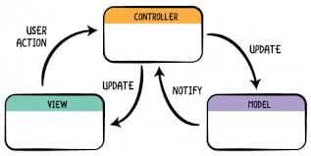

Figure 15: MVC pattern.

Model

The Model represents the datatype which corresponds to all the data-related logic we need to implement the system. It also supports data transferring between the View and Controller

View

The View is used to display for users. It contains all UI logic of the application.

Controller

Controller perform the actions between Model and View that executes all the business logic and requests and responses. Controller uses the Model to produce data then interact with the View to render the final output.

A MVC framework is a combination of these above Model-View-Controller that supports building a web application easily. It creates a mechanism for communication between view and controller which can use Model as data type or database interaction.

***2.2/ Spring MVC***

Spring MVC is one of the most popular framework for Java web developer and its architecture is based on MVC framework.

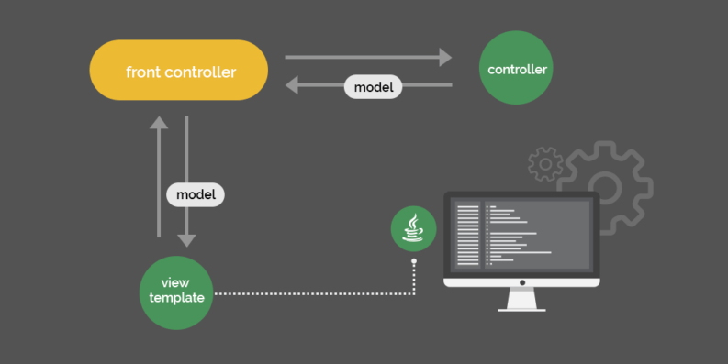

Figure 16: Spring MVC framework architecture

Because it follows MVC pattern, the architecture must be separate into 3 main components: Model, View and Controller and each component work basically similar to MVC framework that I mentioned above. However, in Spring MVC architecture, there is a concept called Front-Controller. It is an initial level of contract point for handling a request. It provides a centralized entry point for that controls and manages web request handling. It also reduces java code and business logic by promoting code reuse ability across the requests. The front controller separates view handling from controller.

Controller just need to handle business logic, connect database, retrieve data or update. It delegates view mapping, annotation configuration and resource mapping to front controller.

On other hand, with RESTController, you can build a RESTful API using Spring framework, which can interact with client and other server side by HTTP methods.

Nowadays, many huge systems apply Spring MVC with 3 layers architecture

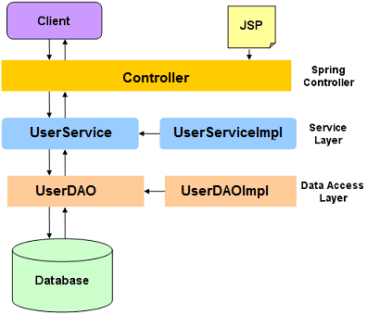

Figure 17: Spring MVC with Three Layer architecture

The reason is to separate the Controller from interact directly with Database or other Data resource. Therefore, we can change the database system or the business logic easily which reduces a lot of risks. Because instead of changing all the code in Controller, we just need to fix the logic in Service or change the way to interact data resource in Data Access Object (DAO).

***2.3/ Hibernate***

Hibernate has a layered architecture which helps the user to operate without having to know the underlying APIs. Hibernate makes use of the database and configuration data to provide persistence services (and persistent objects) to the application.

Hibernate configuration contains database information which helps you to change the database system dynamically.

Session Factory configures Hibernate for the application using the supplied configuration file and allows for a Session object to be instantiated. A Session is used to connect directly to the database system. Each unit of work with the database is represented by a Transaction. Each time you need an interaction with the database, the session object is instantiated which help you update and retrieving data from database system.

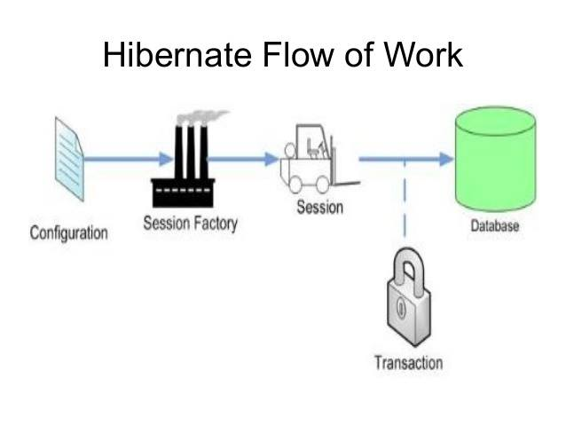

Figure 18: Hibernate architecture

***2.4/ Angular***

Angular is one of the most popular Javascript frontend framework. There are 8 main building blocks of an Angular application in this architecture diagram: Modules, Components, Templates, Metadata, Data binding, Directives, Services and Dependency injection. Their definitions and the way they communicate is describe in brief below:

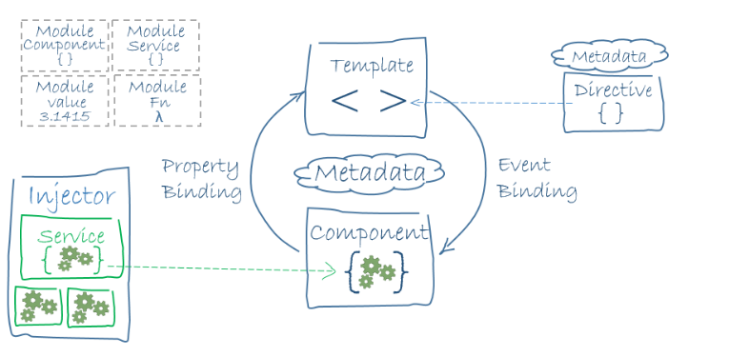 Figure 19: Angular architecture

In each Angular application, there must be one or more Angular module class. The root module is always available in every Angular app.

A component controls the view. We define the application logic in class of the component. That can be fields or functions which support the view. The class and the view interact with each other through an API of properties and methods. We define the view of a component by the template. We can write html code or put html code in the html file to build the template that tells Angular how to render the component Metadata tells Angular how to process a class. Metadata make the class become a component.

Angular supports data binding for coordinating parts of a component with parts of a template. Data binding is added to the template HTML that tell Angular how to connect both sides

The directive is also a class, in directive, we will attach the metadata by the @Directive decorator.

Service is a class, we use service as a category contains any feature, function, value or what we need to use in our application.

In Angular, we provide new com

ponents with the services they need by using dependency injection. Therefore, Angular can tell the components that the types of their constructor parameters may include the services they need

***2.5/ RESTful webservice***

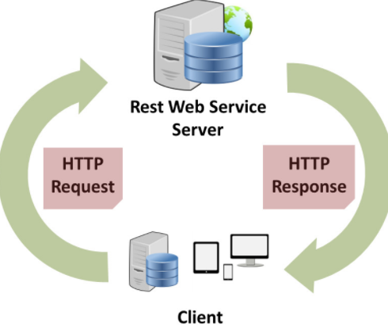

Figure 20: RESTful webservice architecture

RESTful Web Services are Web services based on REST Architecture. They use HTTP methods to implement the concept of REST architecture. URI is usually a service which a RESTful Web Service provides resource such as Text, JSON and XML.

There are 5 HTTP methods are most commonly used in a REST based architecture.

| **HTTP Verb** | **CRUD** | **Entire Collection (e.g. /rooms)** | **Specific Item (e.g. /rooms/{id})** |
| --- | --- | --- | --- |
| POST | Create | 201 (Created), 'Location' header with link to /rooms/{id} containing new ID. | 404 (Not Found), 409 (Conflict) if resource already exists. |
| GET | Read | 200 (OK), list of rooms. Use pagination, sorting and filtering to navigate big lists. | 200 (OK), single room. 404 (Not Found), if ID not found or invalid. |
| PUT | Update/Replace | 405 (Method Not Allowed), unless you want to update/replace every resource in the entire collection. | 200 (OK) or 204 (No Content). 404 (Not Found), if ID not found or invalid. |
| PATCH | Update/Modify | 405 (Method Not Allowed), unless you want to modify the collection itself. | 200 (OK) or 204 (No Content). 404 (Not Found), if ID not found or invalid. |
| DELETE | Delete | 405 (Method Not Allowed), unless you want to delete the whole collection—not often desirable. | 200 (OK). 404 (Not Found), if ID not found or invalid. |

Table 2: RESTful webservice HTTP methods

RESTFul Web service provides API as HTTP methods: GET, POST, PUT, PATCH, DELETE which allows other party to call these methods to retrieve data (as json, xml or format), create, update, modify or delete the data store in database system.

***2.6/ Express framework and Nodejs***

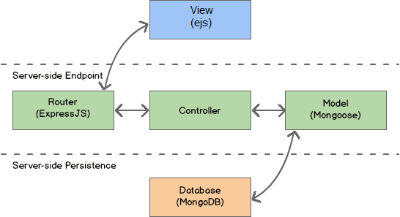

Figure 21: Express MVC architecture

Node.js is an open source framework uses JavaScript on the server side and Express is the most popular framework for Nodejs. The architecture of an express nodejs application should contains 4 main building blocks and based on MVC partten: Model, View, Controller and last but not least the Router.

ExpressJS support Routers to separate the controller and the view. The Routers interact with the view and handle all request mapping and response from the view, they also support building a RESTful API which also provide API to communicate with client side or other party server. Besides, with Mongoose library, the Model in Nodejs can retrieve data or update to MongoDB or another library to interact with other database system. In express framework, Controller uses Model as the data types and interaction with the database as well. Controller also provides data and functions for the routers to render the view (EJS). Router receive request from view and call controller’s functions to update database. On the other hand, router provides API for View (Client side) by building a RESTful webservice

***2.7/ MEAN stack technology***

The term MEAN stack refers to a collection of JavaScript based technologies used to develop web applications. MEAN is an acronym for MongoDB, ExpressJS, Angular and Node.js. From client to server to database, MEAN is full stack JavaScript.

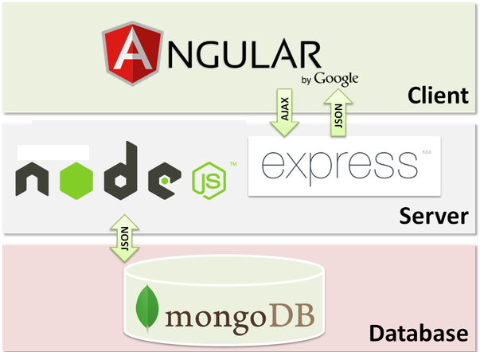

Figure 22: MEAN stack technology architecture

Nodejs and Express framework are on server side, Angular is on client side and MongoDB is a database system that stores data in JSON (JavaScript Object Notation). Angular on client side gets data from Nodejs & express framework on server side in JSON format which may retrieve from MongoDB to represent the view. And in contrast, Nodejs & express framework receive AJAX request from Angular to execute business logic and update to MongoDB.

**Chapter III.** **Software Requirement**

***3.1/ System Overview***

My Hotel Bookings & Reservations System is a web application running on 2 servers. The purpose of running 2 servers at the same time is that each server doesn’t have to do a lot of job and they communicate through API. Because of API, these 2 servers can work independently which means I can apply Microservice architecture to my system.

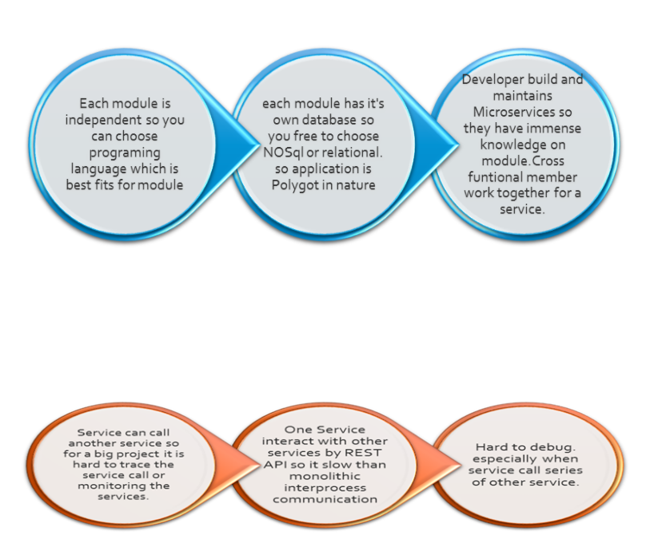

Figure 23: Benefits of Microservice

With Microservice architecture, I can separate my system into many different modules. And each module is independent which means I can choose programing language that best fits for my module and I can also pick which kind of database system that fits with my module, It is the reason why I used MongoDB with Angular, Express & Nodejs and SQL with Spring MVC Hibernate.

Therefore, the system architecture is separate into 2 main architecture includes MEAN stack technology and Spring MVC Hibernate. With MEAN stack technology for Customer’s website, it becomes an online single page application with high performance running on server built by Nodejs and express framework which focus on RESTFULL web service architecture and Angular 2 on client side. This website support dynamically loading with a lot of features for customer as well as provides tracking users feature for Administrator system.

The second main system architecture run on server which was built and deployed by Java and Spring MVC Hibernate. It is a cross-platform flexible and loosely coupled web application runs well on all operating system.

The client side is the combination of HTML5, CSS3, Bootstrap and Angular which provides the very friendly user interface make it easy to use. Hence, the users will feel convenient and comfortable when using this application with about 42 primary feature and hundreds of small features.

***3.2/ Feature***

The users of my system were separated into 3 primary roles: Guest, Customer and Administrator. There are many features that my system support for each role

3.2.1/ Guests

The guest can view introduction and gallery of the hotel, send reservation form, contact with administrators, view, search the rooms or the items in the restaurant which they would like to see more details or register an account to become a customer.

3.2.2/ Customer

The customers can do anything which the guests can do. They can login to the system to book room or cancel it, rate the room, send feedback, check profile, view transaction history. With data collection feature, customers were tracked; therefore, the system can suggest the recommendation rooms for the customers.

3.2.3/ Administrator

The admin can login to the website and go to their dashboard to manage the hotel, check his profile, add, update and delete rooms or other services in the restaurant, receive the request of customers and reply them with several available email templates. Admin can also manage the users, view information and activity of users or ban them if they did something unacceptably.

Thank to follow-users feature, administrator is able to see which page customers clicked, how long they stayed in each page, which keyword they used to search, which image they used to click on. Admin can view the chart with the statistics of visitor from country as well.

There are a lot of features in my system. The table below show list of primary features in my system

|  |  |  |  |
| --- | --- | --- | --- |
| **No.** | **Feature** | **User** | **Description** |
| 1 | Register | Guest | The guest can create new account |
| 2 | Login | Customer, Admin | Customer, Admin can login to use more feature |
| 3 | Logout | Customer, Admin | Customer, Admin can logout |
| 4 | View Rooms | Guest, Customer, Admin | Customer, Admin can view list of rooms in hotel |
| 5 | View Restaurant | Guest, Customer, Admin | Customer, Admin can view list of restaurant items in hotel |
| 6 | Search for Room | Guest, Customer, Admin | Customer, Admin can input to search for room |
| 7 | Search for Restaurant Item | Guest, Customer, Admin | Customer, Admin can input to search for restaurant items |
| 8 | View gallery of hotel | Guest, Customer | Guest, Customer can view image gallery of hotel |
| 9 | View introduction of hotel | Guest, Customer | Guest, Customer can view introduction of hotel |
| 10 | Filer rooms | Guest, Customer, Admin | Guest, Customer, Admin can filter the list of rooms by their attribute |
| 11 | Filer food or drink | Guest, Customer, Admin | Guest, Customer, Admin can filter the list of restaurant items by their attribute |
| 12 | Send contact | Guest, Customer | Guest, Customer can send contact form to administrator |
| 13 | Send reservation form | Guest, Customer | Guest, Customer can send reservation of booking form to administrator |
| 14 | Book room | Customer | Customers can book room using account balance |
| 15 | Cancel room | Customer | Customers can cancel rooms they booked |
| 16 | View profile | Customer, Admin | Customer, Admin can view personal information in profile page |

|  |  |  |  |
| --- | --- | --- | --- |
| **No.** | **Feature** | **User** | **Description** |
| 17 | Edit profile | Customer, Admin | Customer, Admin can edit personal information in profile page |
| 18 | Change password | Customer, Admin | Customer, Admin can change password |
| 19 | View activity | Customer | Customers can view their transaction history with all of their activities |
| 20 | Send feedback | Customer | Customer can send feedback with rating score and comment |
| 21 | Dashboard management | Admin | Admin can view dashboard page with chart and notification |
| 22 | Receive notification | Admin | Admin can receive notification from customer and guest |
| 23 | Send message | Admin | Admin can send message via email for customer |
| 24 | View users | Admin | Admin can view user information |
| 25 | Manage users | Admin | Admin can manage what user have done on the website |
| 26 | Ban users | Admin | Admin block the users |
| 27 | Add new room | Admin | Admin can add new room to db system |
| 28 | Delete room | Admin | Admin can delete room from db system |
| 29 | Update room | Admin | Admin can edit room |
| 30 | Add food or drink | Admin | Admin can add new restaurant item to db system |
| 31 | Remove food or drink | Admin | Admin can add remove restaurant item from db system |
| 32 | Update food or drink | Admin | Admin can change restaurant item information |
| 33 | Update profile image | Admin | Admin can change profile image |
| 34 | Follow users | Admin | Admin can view the tracked data of user |
| 35 | Send feedback & rate hotel | Customer | Customer can send feedback with rating and comment about hotel service |
| 36 | Send feedback & rate room | Customer | Customer can send feedback with rating and comment about room |
| 37 | View customer Data collection | Admin | Admin can view customer transaction history as statistics data |
| 38 | View chart | Admin | Admin can view chart by tracked data from users |
| 39 | View recommendation room | Guest, Customer | Guest and Customer can view the room they should book which is suggest automatically by system |
| 40 | View related item | Admin | Admin can view relate items such as room, restaurant item when they stay on a item page details |
| 41 | View top of rooms | Guest, Customer | Guest, Customer can view room which automatically sort by the highest rating score |
| 42 | Email template | Admin | Admin have a email template for sending email to user |

Table 3: List of features

***3.3/ Use Case***

Based on the feature above, I have a use case diagram below with 3 actors using the system: guest, customer and administrator



Figure 24: Use Case Diagram

***3.4/ User Story***

According to the Use Case diagram, it will drop down into 25 user stories:

* As a guest, I can register a new account so that I can login to the system
* As a guest, I can view the rooms so that I can see the details of the rooms, watch the image of the rooms.
* As a guest, I can view the food or drink in the restaurant of the hotel so that I can see the details, watch the images of each item in the restaurant.
* As a guest, I can view introduction and gallery page so that I can see the information of the hotels and watch the image gallery of the hotel.
* As a guest, I can send contact to the administrator so that I can write what I want to communicate with him and wait for his response.
* As a guest, I can view the recommendation rooms so that I can see which room that the system automatically suggests me book.
* As a customer, I can login to the system or logout so that I can use more features.
* As a customer, I can edit my profile so that I can change my personal information.
* As a customer, I can book room so that when I come to the hotel, this room belongs to me,
* As a customer, I can send a feedback about a room or about the whole hotel services so that I can rate the star of service and comment or complaint my opinion.
* As a customer, I can view my activity so that I can see the transaction history, what I have done, what I interacted with the hotel.
* As an administrator, I can login to the system or logout so that I can use admin features.
* As an administrator, I can edit my profile so that I can change my personal information.
* As an administrator, I can manage the rooms so that I can view the rooms, add a new room, edit a room or delete it.
* As an administrator, I can manage the items in restaurant so that I can view the items, add a new item, edit an item or delete it.
* As an administrator, I can manage users so that I can view user information, view what they interacted with hotel or delete a user from database.
* As an administrator, I can view my messages and notifications which the guests or customers send to me so that I can interact with them and reply their message.
* As an administrator, I can follow user’s behavior so that I can see what they clicked, what they searched, what they did on the website.
* As an administrator I can view the visitor chart from country so that I can easily compare which is the most visited country, which is the less visited country and another.
* As an administrator I can view the page access chart based on all IP address or single IP address so that I can easily compare which is the most visited page, which is the less visited page and another.
* As an administrator, I can receive the message, the booking request, cancel room request and feedback of the customers so that I can view the information that they send to me and reply them by myself or using some available email templates

**Chapter VI.** **Methodology**

***4.1/ All Technology used***

To build the above system I need to use and apply a lot of technology.

As I mentioned above, for Server side, I used Java web J2EE with Spring MVC and Hibernate Framework for Administrator sites. On another hand, I used Node.js & Express Framework to develop server for Customer sites. I also used HTML5, CSS3, Javascript, JQuery, Boostrap with AngularJS & Angular 2 Framework for client side. Moreover, I used 2 kind of database system: MongoDB (NoSQL) and SQL. Because of Hibernate, I can also test running the system on 2 different SQL database system: Mircosoft SQL Server and MySQL without changing the query.

Besides, I used UMLET and Edraw to design UML and draw diagram. For coding Nodejs, Java and Angular, I some need IDE tool such as VSCode, Eclipse, Netbeans.

To design and code front-end with HTML, CSS and JS, I used Adobe Dreamweaver CS6.

To build and deploy the server I used maven with tomcat or glassfish for java server and node_modules with npm for Node.js server

I would like to list some other tool, software, framework or library that supported me to build my system:

Code review and analysis: Sonar Lint

Version Control: Git hub

Project management: Trello

Some Library: gson, geoip, mail service, jackson, external IP and so much more.

***4.2/ System Architecture***

My system includes 2 main architectures: one for Customer which applied MEAN stack technology and one for Administrator built in AngularJS with Spring MVC Hibernate.

They are built and deployed in 2 different servers and communicate through API.

The system architecture includes MVC architecture and RESTful Webservice with Angular Architecture

4.2.1/ MVC architecture

Nodejs & Express framework MVC

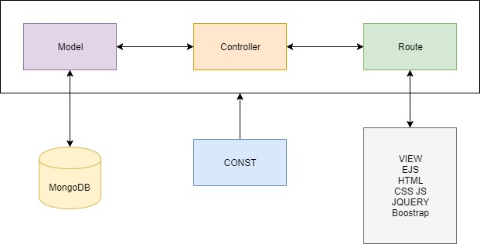

Figure 25: Nodejs and Express MVC framework system architecture

This architecture is based on MVC achitecture with Nodejs & Express frameowork on server side. The request of customer from view EJS to Routes which call the functions from Controller to delegate Models interact with MongoDB to retrieve or update the database and then send response backward from Model to Controller to Route and display by EJS for Customer. The CONST provide constant variables for the whole system.

4.2.2/ Spring MVC Hibernate

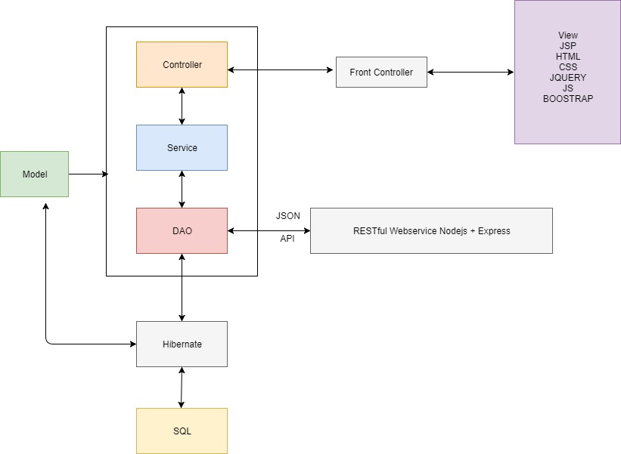

Figure 26: Spring MVC Hibernate system architecture

This is another MVC architucture build by Spring MVC and Hibernate framework on server side. The request of Administrator from JSP to FrontController which handles the view mapping before sending to Controller. After that, the Controller will call method from Services which use the methods from DAOs to connect database. The Models provide datatype for Controller, Services, DAOs which is mapped with Hibernate to persist SQL database system. The Helper class provides some additional functions; the AppConst and APIConst provide constant application data and constant API URL link as public static final variables for the whole system. Similar to request process, the response process will execute in opposite direction.

4.2.3/ RESTful Webservice architecture

Nodejs & Express framework RESTful webservice

Based on Nodejs Express MVC architecture above, this architecture has the same structure but it is the webservice and it has no view. Therefore, the routes became the API routes which provide API as HTTP method for Angular on client side or other application instead.

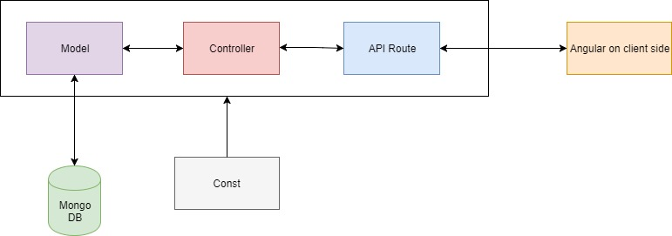

Figure 27: Nodejs and Express framework RESTful webservice system architecture

4.2.4/ Spring Hibernate RESTful webservice

This architecutre follow the Spring MVC Hibernate structure and similar to the REST architecture above. It is a webservice provide API by RESTController.

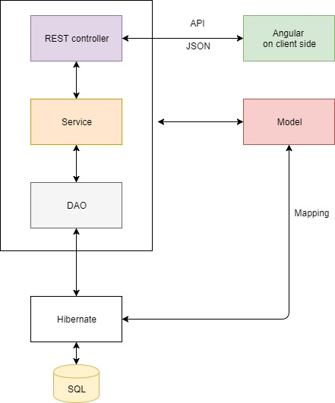

Figure 28: Spring Hibernate RESTful webservice system architecture

4.2.5/ Spring RESTful webservice interact other RESTful webservice

This is a RESTful webservice architecture which is the combination of Spring RESTful webservice and ability to interact with other API provider. In this case, the DAO communicate with Nodejs & Express RESTful webservice in section 4.2.1 to provide data as well as update to MongoDB database system

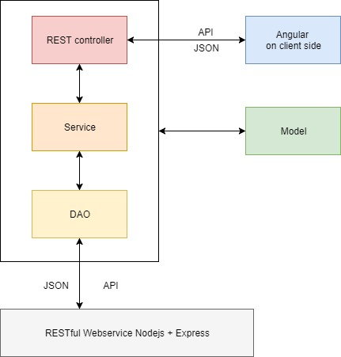

Figure 29: Spring Hibernate RESTful webservice interacts other REST API system architecture

4.2.6/ Angular on client side architecture:

In my system, Angular can communicate directly with the RESTful Webservices above through API.

4.2.6.1/ AngularJS architecture

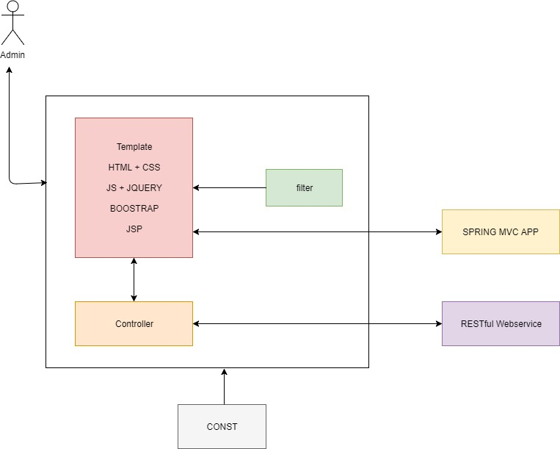

Figure 30: AngularJS system architecture

Request of Admin from JSP files which include HTML, CSS, JS, JQuery, bootstrap and AngularJS is controlled by Spring MVC App. Besides, with AngularJS on client side, the data binding mechanical can be used between AngularJS Templates and Controllers which have functions to interact with RESTful Webservice. Moreover, the AngularJS filters provide the methods to transform data in the template and AppConst provides const variable for the whole client-side with AngularJS application.

4.2.6.2/ Angular 2 architecture

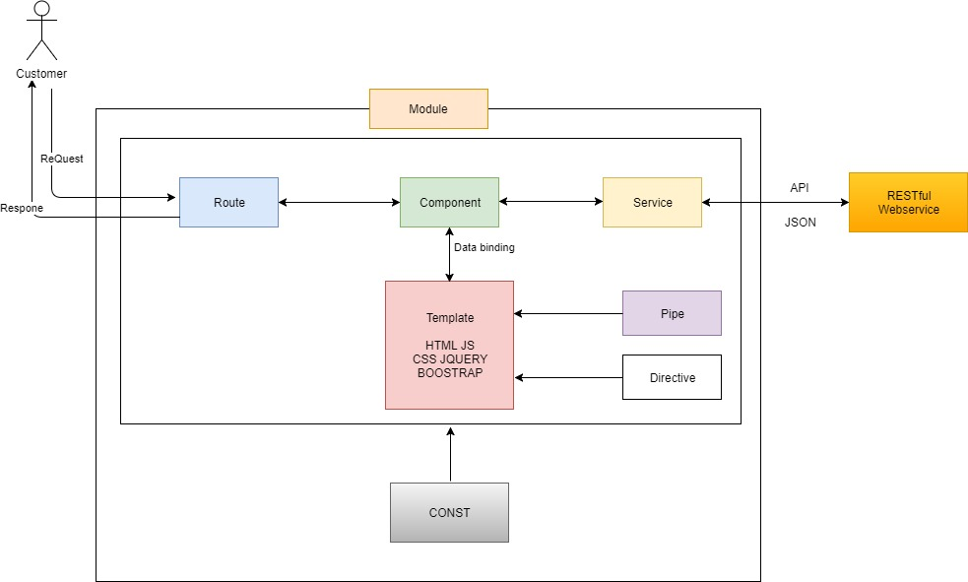

Figure 31: Angular 2 system architecture

Arcoding to the diagram above, when the customer sends request to Angular 2 app, it first handles the view mapping by Routes then they will send exactly this request to component. Similar to AngularJS but the controllers are removed and changed to Component, the data binding mechanical now occurs between Component and Template. Sevices take responsibility for communication with RESTful webservice through HTTP methods. Directive supports change the structure of the view, it also help change the style of elements and so much more. The CONST and Pipes work the same as CONST and Filters in AngularJS architecture in section 4.2.6.1.

4.2.7/ Full system architecture:

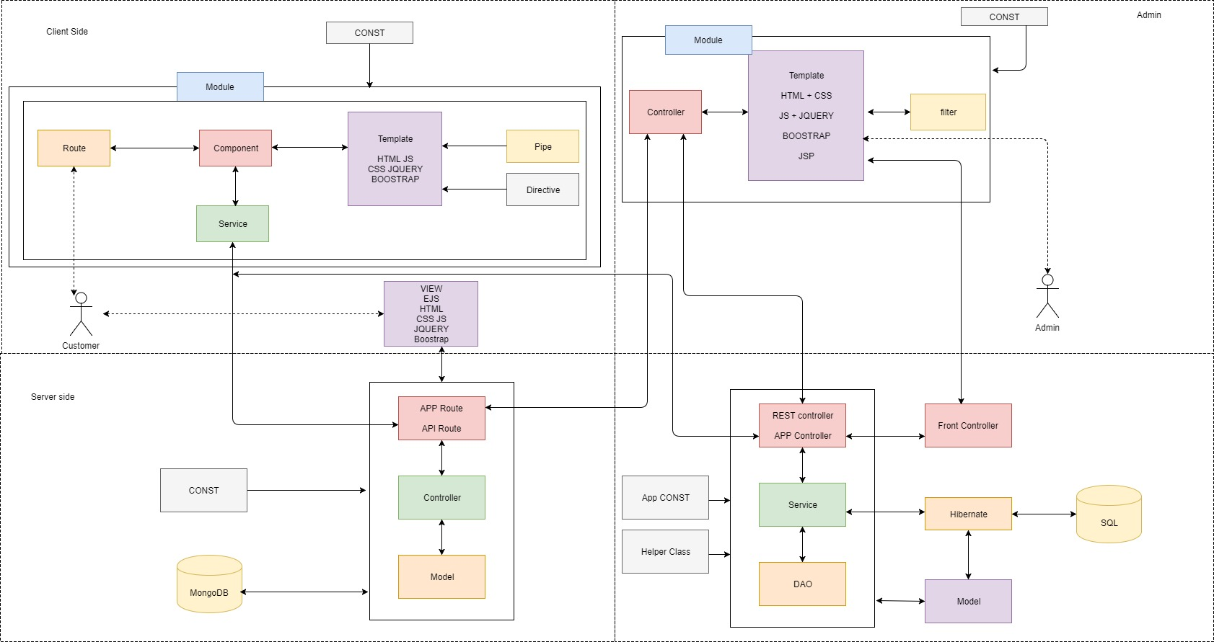

Figure 32: Official system architecture

This is the combination of all architectures from section 4.2.1 to 4.2.6

Based on the system architecture above, you can easily see that the Clients which include Angular communicate with the Servers through API. The server built by Nodejs and Express framework connect to MongoDB and the second server built by Spring MVC connect to SQL to store or provide data for client through API. Moreover, 2 servers can also interact with each other by their own provided API. That is one of the most popular architecture in many big companies today called Mircoservice.

***4.3/ Database system***

With 3 actors using the system showed in use case (section 2) and based on 2 main servers for Guest, Customer and Admin. I separate the Database system into 2 primary part: MongoDB and SQL

4.3.1/ MongoDB collection & document

There are 4 collections in MongoDB include customer, activity, tracking and suggestion-data

Collection Customer contains Customer personal information, username & password

Collection Activity contains Some activity of customer. It is also the transaction history which includes some transactions such as: create new account, book room, cancel room, send contact, send reservation form.



Figure 33: MongoDB collections

Collection Tracking contains tracking data of user such as the IP address, the external IP, the page user clicked and the duration that user stays in this page.

Collection suggestion-data contains the data to recommend room for user. The data include the average size, average price, average amenity of the rooms that customer view, click, book or search.

4.3.2 / SQL ERD (Entity Realationship Diagram)

Figure 34: SQL Entity Relationship diagram

According to the entity ralation ship diagram above, we can easily see all the fields of each table and how they work together.

Table admin contains all administrator information, username and password.

Table Room contains all information of room which booking details includes who booked the room, check in date, check out date.

Table RestaurtantItem contains all information of the items in restaurant includes food, drink, fruit or ice-cream.

The realationship is that one Admin cans create a lot of Room or a lot of RestaurantItem so that in there is a field username in these 2 tables that maps with the username of an Administrator

4.3.3/ MongoDB interact with SQL ERD

Combine the collection of MongoDB and table of SQL database system, we have this relationship below:



Figure 35: MongoDB collections and SQL Entity Relationship diagram

***4.4/ Class diaram***

Based on these system architectures and database structures above, with mircoservice architecture and 2 database system; It is not easy to draw the class diagram in one page because the system is too big. Therefore, I separated it into smaller class diagrams in section 4.4 below:

4.4.1/ Model

4.4.1.1/ Relationship Model

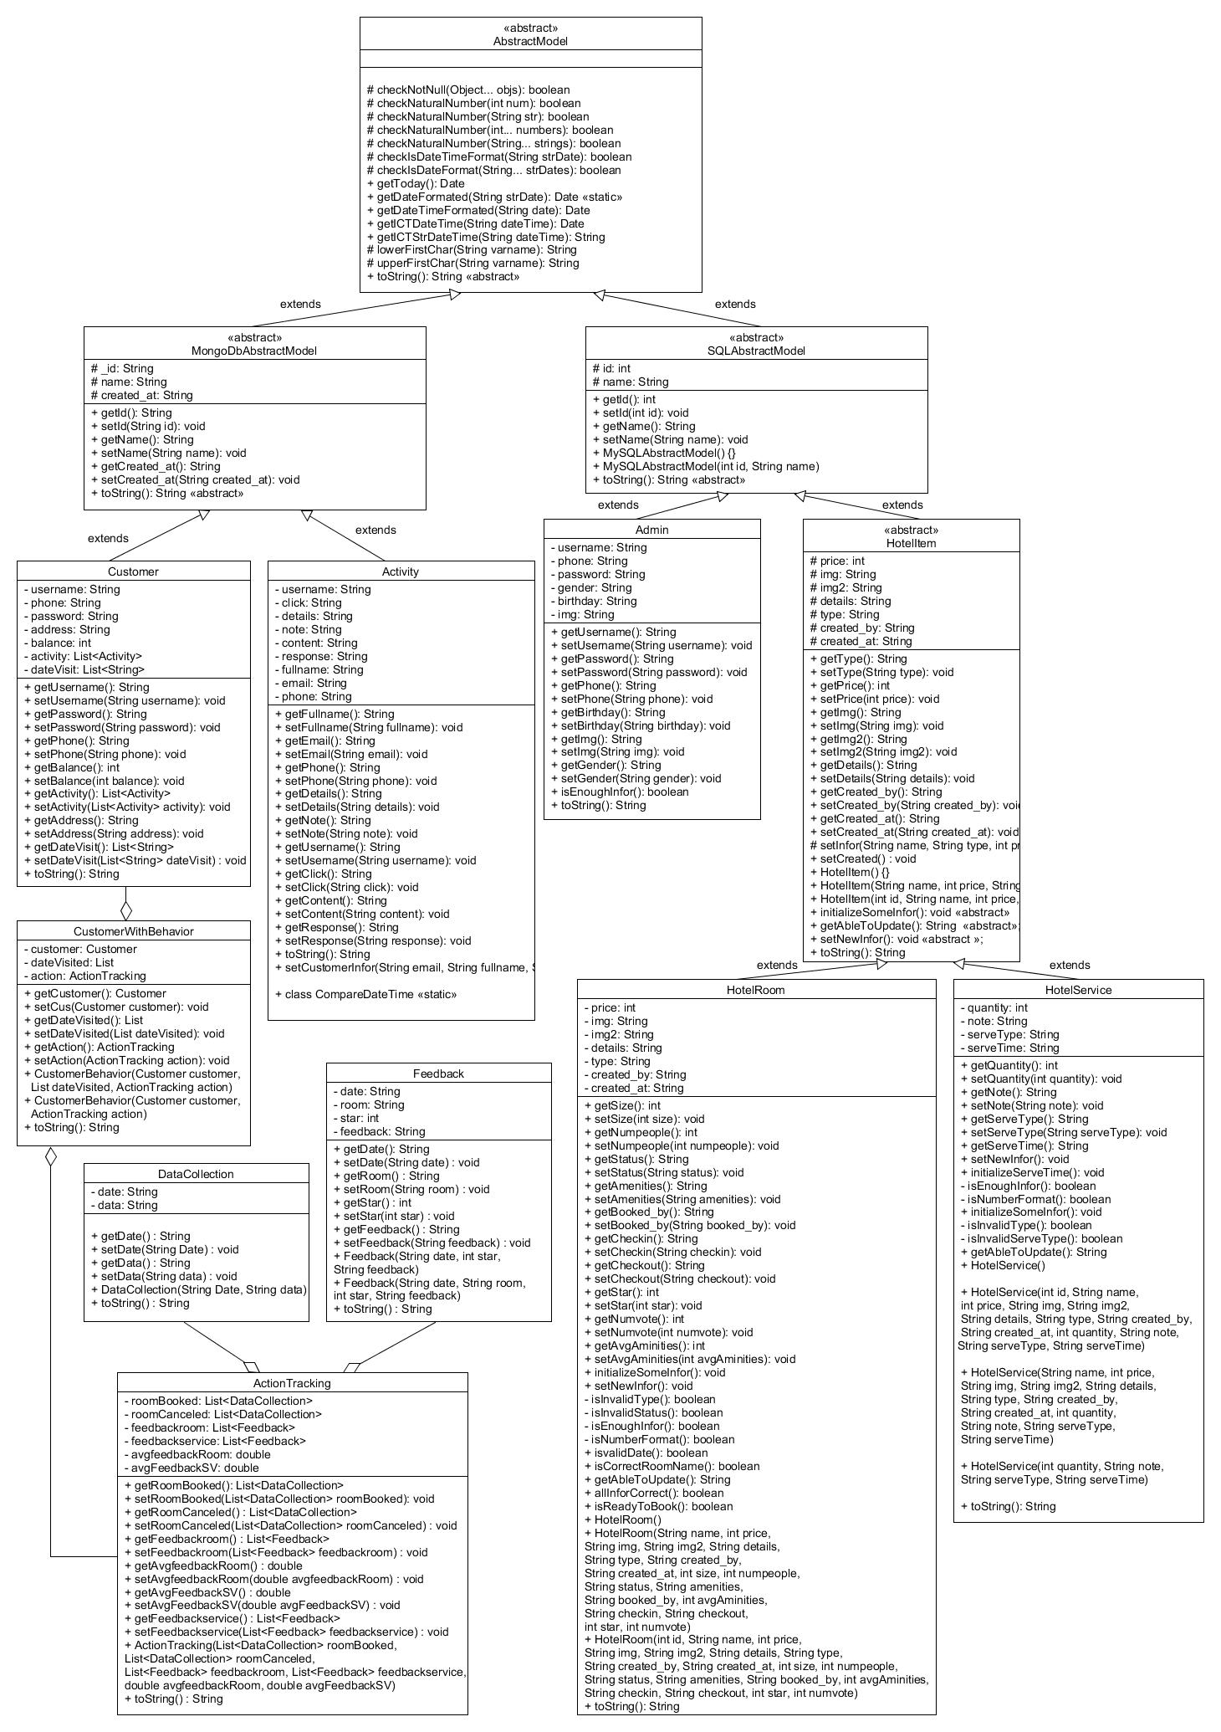

Figure 36: Spring Model class diagram

The class diagrams above represent clearly the models with their relationship and all variables, methods of each class. I just want to describe in short how they work:

The AbstractModel is an abstract class contains some checking function, get datetime in serveral format and some addition functions for its subclass.

The MongoDBAbtractModel and SQLAbtractModel are 2 abstracts class extends AbstractModel which represent for 2 kind of database system MongoDB & SQL.

With each database system, I created several corresponding models. For MongoDB, we have Customer, Activity extends MongoDBAbtractModel and some related class includes CustomerWithBehavior, ActionTracking, DataCollection, Feedback.

Class Customer contains all information of customer with username and password.

Class Activity contains all customer’s activity includes book room, cancel room, send feedback, rating room, send contact, send reservation form.

Class CustomerWithBehavior owns the Customer class and the list of date customer visited the hotel website. Moreover, this class also contains some addition behavior of customer that store in ActionTracking class which includes average rating point for room and hotel service. the action that tracked by system such as list room booked, list room canceled, list of feedback or list room feedback declared in Feedback class with feedback time, which room, rating and comment.

On another hand, for SQL database system, there are 2 primary main models called Admin and HotelItem. The HotelItem class has 2 subclasses HotelRoom and HotelService. All 4 models are mapped by Hibernate with corresponding tables includes admin, room, restaurant in SQL database.

Class Admin contains all information of admin with username and password.

HotelItem is an abstract class contains some variables that HotelRoom and HotelService should use such as name, size, price, type… and some abstract methods for its subclass to override such as initialize some information, set new information or return the ability to update new data…

HotelRoom class contains all information of room such as amenity, average amenity score, rating score, image, details with some checking method like check valid type, valid status, enough information of room, room is ready to book or not…

HotelService class contains all information of hotel service item. In my case, the hotel service items are only the items sold in hotel restaurant. The information include quantity, note, service type, service time and function for compute the service time, checking whether a service item has valid type, enough information, correct server type or not.

4.4.1.2/ Bean and POJO classes

Besides, there are some pojo models without any relationship with other models. They just provides data type for Spring system.

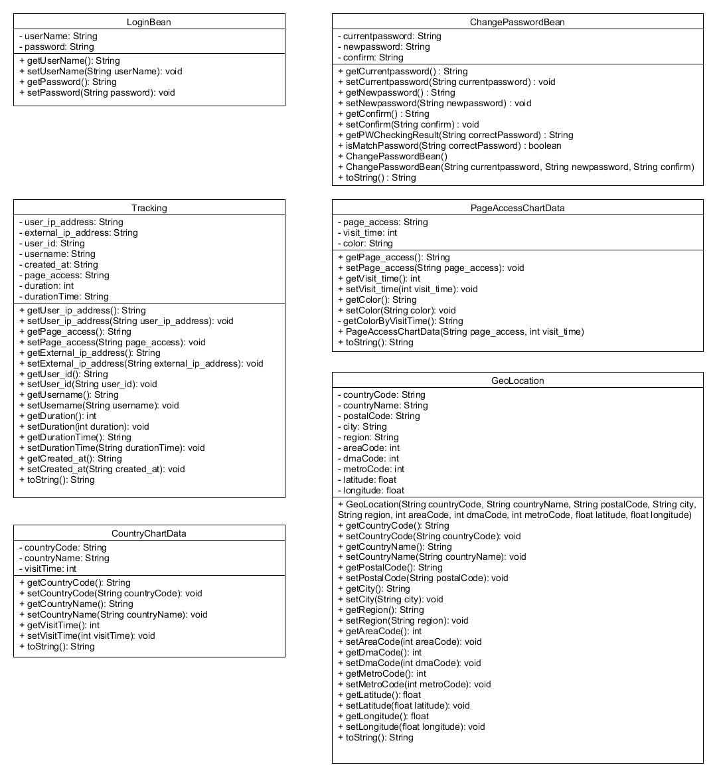

Figure 37: Spring Bean and Pojo class diagram

The LoginBean and ChangePasswordBean are 2 java bean contains data such as username, password, new password, confirm password, current password to support login and change password feature

The Tracking class contains information tracked such as ip address, external ip, username, the page which user accessed and the duration in millisecond format and hh/MM/ss: SSS format

The CountryChartData and PageAccessChartData declare the necessary data to draw chart a country chart and page access chart based on visit time

The GeoLocation class contains tracked information based on geo location which includes country, city, region, postal code, area code, DMA code, metro code and the coordinate of user ip address.

4.4.2/ DAO

There are 2 kinds of DAO named Hibernate DAO and API DAO which have the following meaning:

4.4.2.1/ Hibernate DAO

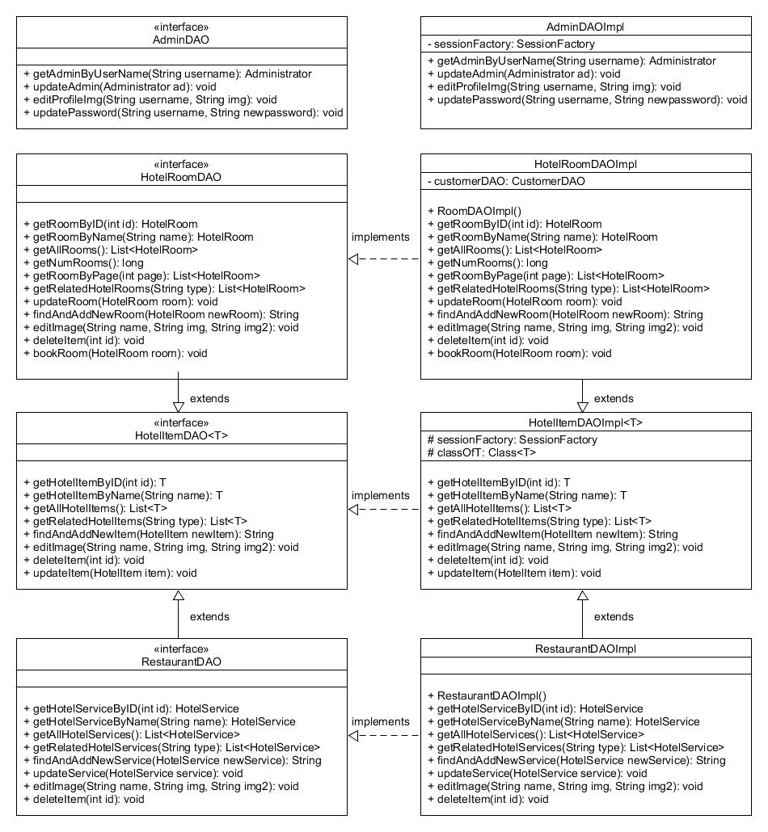

Figure 38: Spring Hibernate DAO class diagram

Firstly, Hibernate DAOs are the interfaces that inject the session factory follow Hibernate and Spring framework to interact with SQL database system

The main purpose of them is working with Hibernate and SQL Model (see in section 4.4.1.1) to interact with SQL for retrieving data or update then provide methods for Services.

Interface AdminDAO use Admin model mapping with table admin in SQL provides some methods such as: get Admin by username, edit admin, edit admin profile image, change admin password…

Interface HotelItemDAO use HotelItem model provides some methods relate to room and restaurant such as: get Hotel Item by id, by name, by the same type as another item; get all Hotel Item as a list, insert, update or delete hotel item; change image of item…

Interface RoomDAO use HotelRoom model; mapping with table room in SQL and extends HotelItemDAO so it can use the super methods from HotelItemDAO to provides some methods such as get Room by id, by name, by the same type as another room; get list all rooms; get list of some rooms for each page and also edit image, insert; update; delete room…

Interface RestaurantDAO use HotelService model; mapping with table restaurant in SQL. It also extends HotelItemDAO and have the similar method to RoomDAO but relate to restaurant instead of room…

4.4.2.2/ API DAO

Secondly, API DAOs are also the interfaces but instead of expectation SQL for data, they interact with webservice as a data storage.

APIDAO is an interface provides a function support retrieving data so that the CusomterDAO, ActivtyDAO and TrackingDAO can extends and use this function. These classes use the correspond MongoDB models includes Customer, Activity, ActionTracking, CustomerWithBehavior, DataCollection, PageAccessChartData and CountryChartData.

Interface CustomerDAO contains some methods such as get customer by username, get all customers, get customer behavior…

Interface ActivityDAO contains some methods relate to Activity, Notification and Message

Interface TrackingDAO contains some methods relate to Tracking Data, Statistic and Chart

All these DAO Interfaces have their implementation which are AdminDAOImp, HotelItemDAOImp, RoomDAOImpl, RestaurantDAOImpl, APIDAOImpl, CusomterDAOImpl, ActivtyDAOImpl and TrackingDAOImpl, These classes will clarify the methods that I just mentioned above.

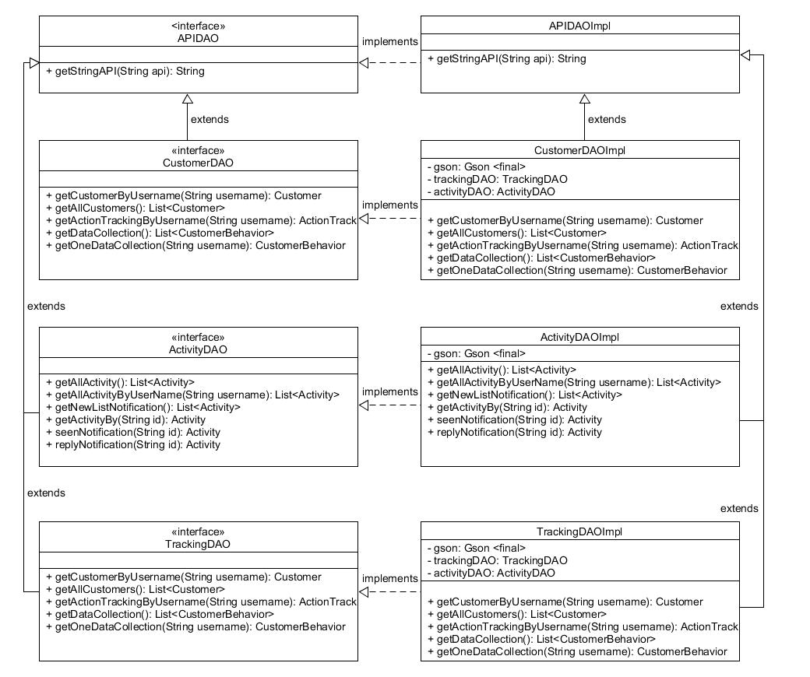

Figure 39: Spring API DAO class diagram

4.4.3/ Service

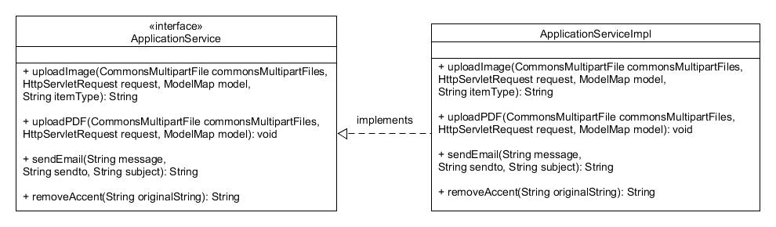

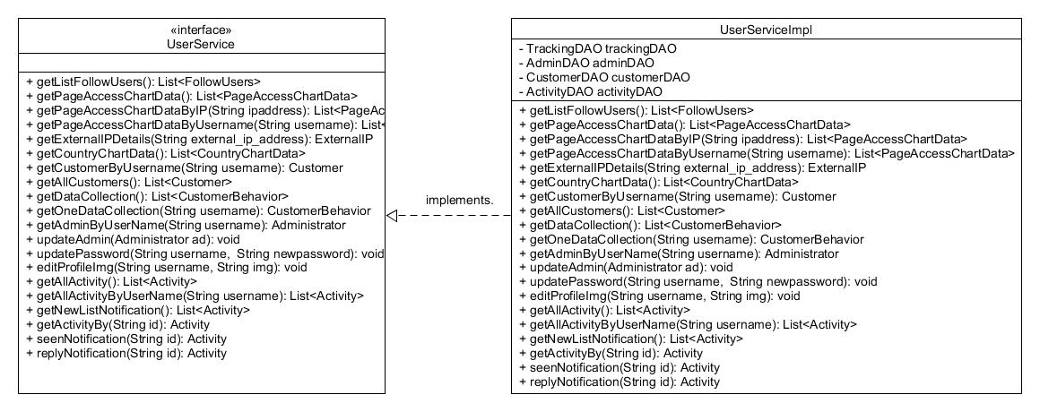

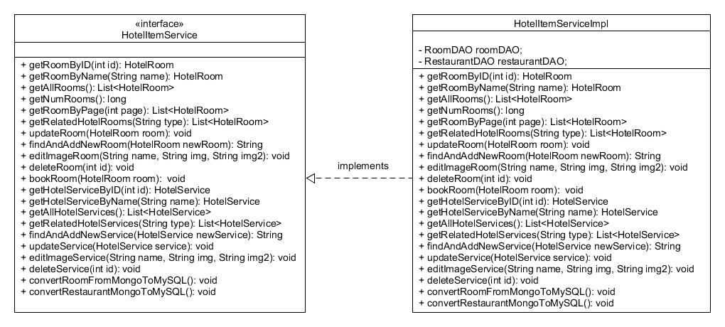

Figure 40: Spring Service class diagram

These Services use the corresponding DAOs methods to build functions for Controller. Their methods are process directly from DAOs to Services to Controllers through Dependence Injection of Spring framework which also use the models as datatype.

4.4.4/ Controller

The Controllers interact directly with Services to use their methods for doing the business logic then return data for JSP to display or be a RESTful webservice provides API for another server or client side.

There are 2 kind of Controllers supported in my Spring framework application. There are RESTController and AppController with handle their own jobs in my system. Each controller maps with an URL so that user can access this URL on browser.

4.4.4.1/ REST Controller

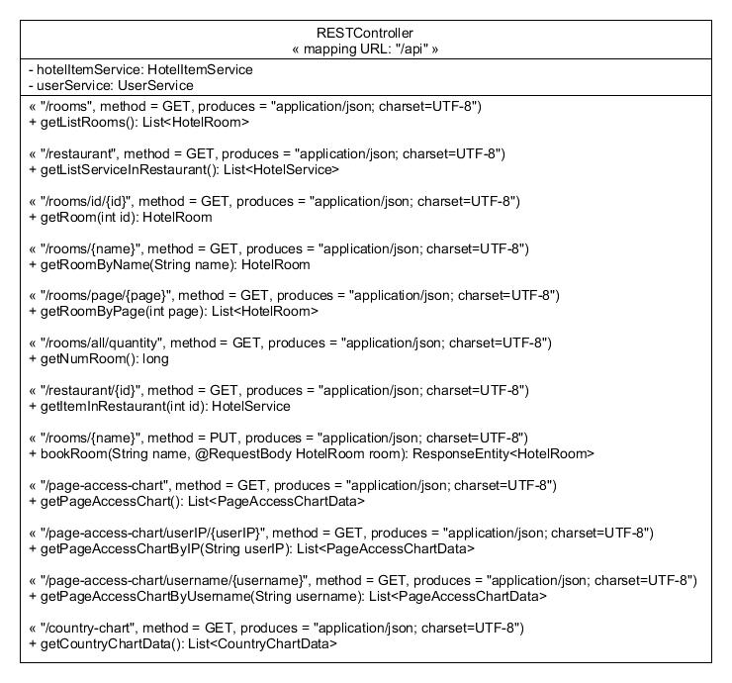

Figure 41: Spring REST Controller class diagram

The RESTController contains methods for building RESTful webservice. All the methods are mapping as URL: /api/{api-endpoint} which HTTP method: GET, PUT, POST, DELETE …

api-endpoint is the exactly end point mapping with any API which RESTController provides.

There are several methods that this RESTAPI provides data for other app by HTTP GET method such as get all rooms, get list rooms by page, get room by name, get restaurant item, get page acess chart data …

It also has other HTTP methods such as book room method using HTTP method: PUT. This method allows other application to update booking information to table room without communicate with SQL database server.

4.4.4.2/ App Controller, Front Controller and JSP

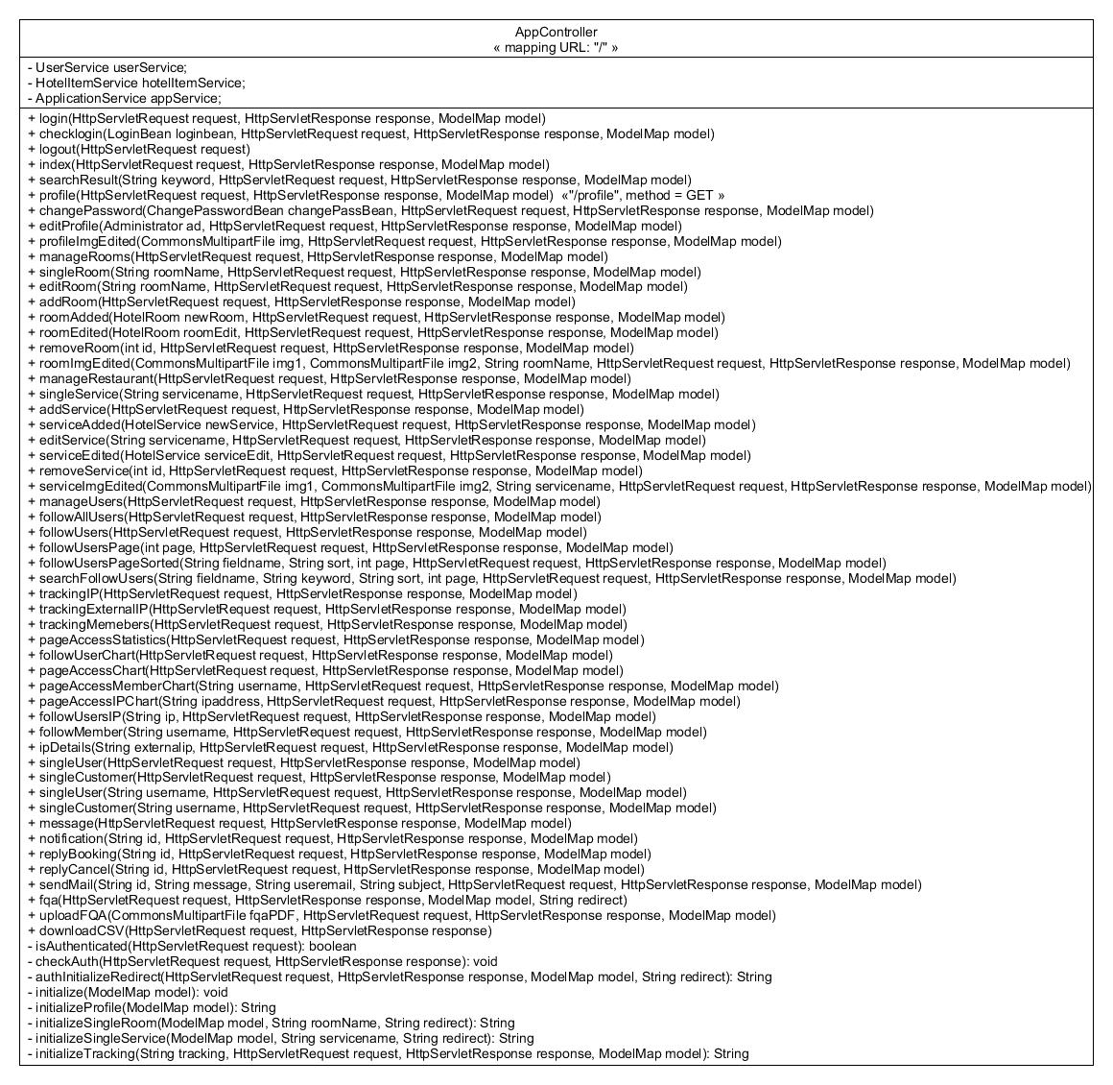

Figure 42: Spring App Controller class diagram

On another hand, the AppController represents all mapping URLs for admin website that interact with JSP files declared mapping in FrontController. The AppController also handles the business logic when admin sends a request from client side (JSP) and response.

I put the JSP file name similar to AppController methods for easily working. we you can see the diagram about AppCountroller and JSP in figure 43 to understand how they work

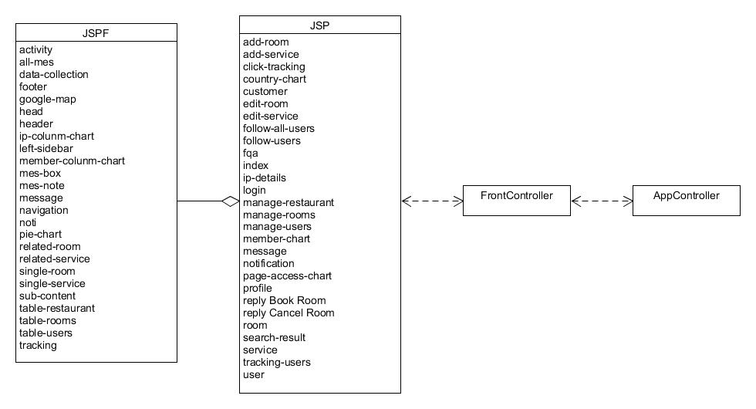

Figure 43: Spring JSP class diagram

The JSP files which include JSPF files for resuse code in JSPF files. The JSPs communicate with AppController by mapping in FrontController.

The FrontController handle view mapping before do bussiness logic in AppController. In my case, I use this bean to mapping:



This bean help FrontController mapping with the URL available in AppControler by Anotation ResquestMapping with Request Method is GET or POST.

When ever admin view a page, click another page without any involve anything, like storing or updating data, or upload file, or sending E-mail. For example, admin go to index page, view manage room page, view notification … The AppController will performs the corresponding RequestMapping method with Request Method GET to interact with FrontController for display the JSP file on browser.

For Request Method POST such as login, send email, edit profile, change password, add room, upload fqa file, … The AppController get the parameter from JSP then do bussiness logic and return a next JSP page for admin.

The Front Controller also declare a lot of mapping or anotation config for J2EE web application like mapping package, resource, view resolver, hibernate …

You can have a look at FrontController in figure 44 below:

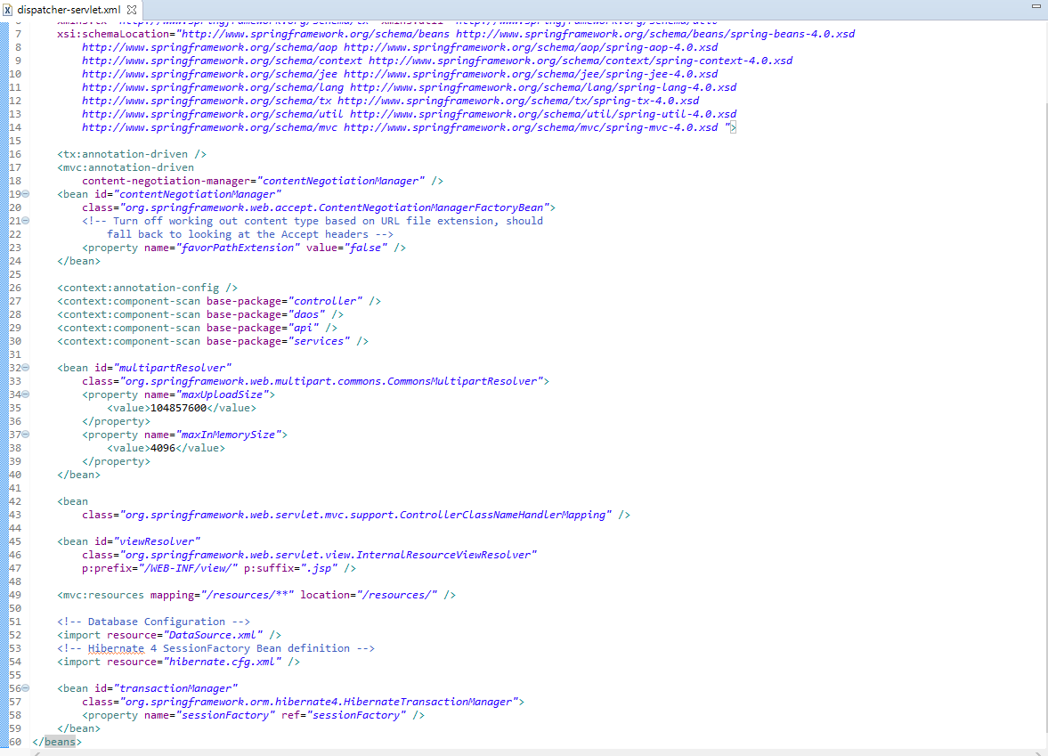

Figure 44: Spring Front Controller

4.4.5/ CONST and Helper classes

While implement the system, I need some classees that support me calll directlly the methods as well as the variables without following the process from DAO to Service to Controller.

The CONST classes and Helper Classes helped me pass my reqiurement successfully.

4.4.5.1/ CONST Classes

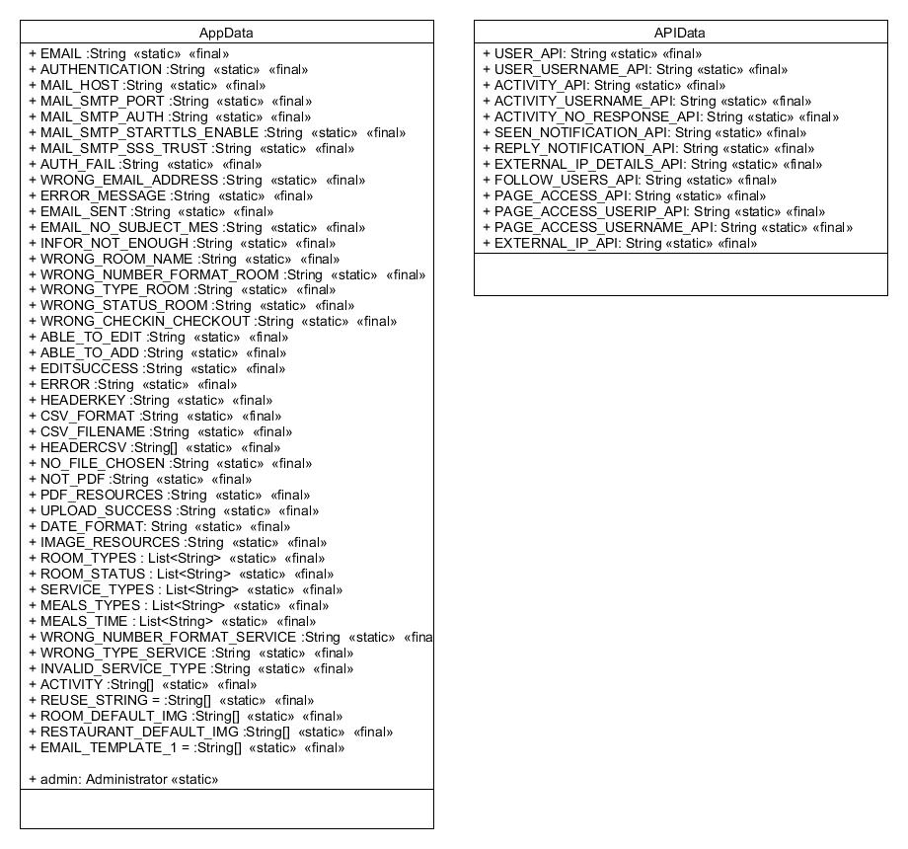

Figure 45: Spring CONST class diagram

These classes contain a lot of Constant variables for the whole Spring application use. The different between them is that the AppData includes variables for configuration, error message. Infor message, constant variable for email sending, csv uploading. Besides, the APIData only contains Constant variable related to API. These 2 classes help refactor code easily and solve the hard coding problem.

4.4.5.2/ Helper Classes

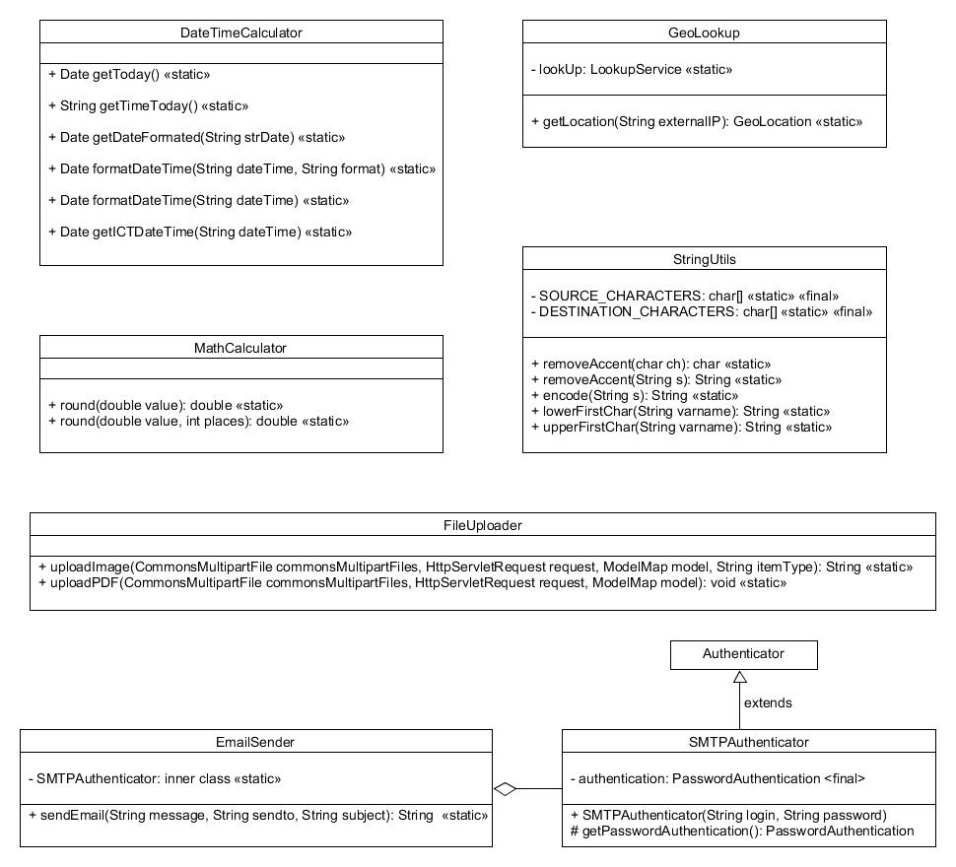

Figure 45: Spring Helper class diagram

These classes contain some methods for the whole system which do not really need any business model. Their methods work independently but they are very necessary. In my system, I need to format datetime a lot because I use 2 kinds of database system MongoDB and SQL; their datetime format are different. Moreover, to work with String and Number is not very easy, MathCalculator and StringUtils help me to solve this problem.

My system also support email sending, file uploading and geo location lookup feature so that I need 3 class EmailSender, FileUploader and GeoLookup.

4.4.6/ Offical Spring Class Diagram

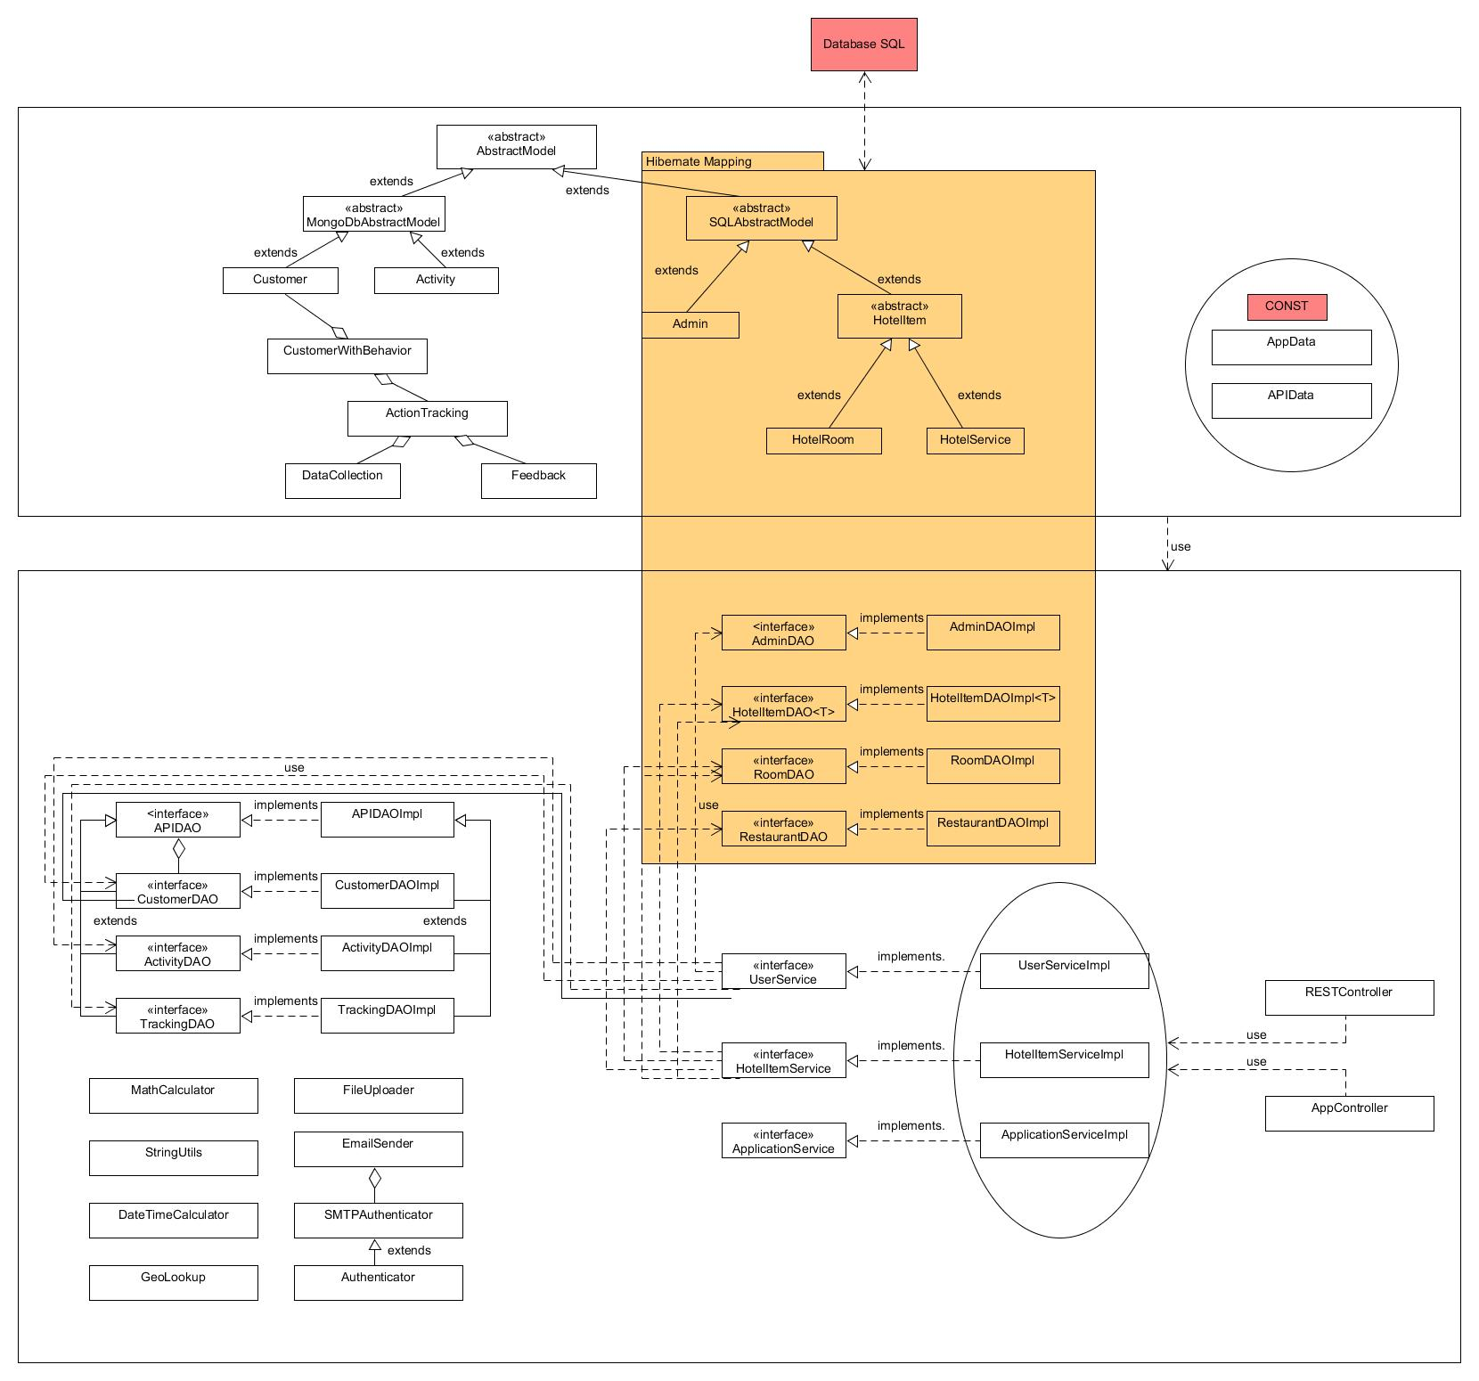

Figure 46: Offical Spring class diagram

This class diagram is combined by all the class diaram from section 4.4.1 to 4.4.5

You can see that the

The UserService uses methods from CustomerDAO, ActivityDAO, TrackingDAO and AdminDAO

The HotelItemService use smethods from HotelItemDAO, RoomDAO and RestaurantDAO

The ApplicationService uses almost methods from Helper classes

These Services provide methods for Controller and RESTController

All the process goes though Dependence injection supports by Spring ioC container.

The Models provide datatype for application, the CONST and Heper classes provides constant variables and methods for the whole system.

4.4.7/ Model-JS

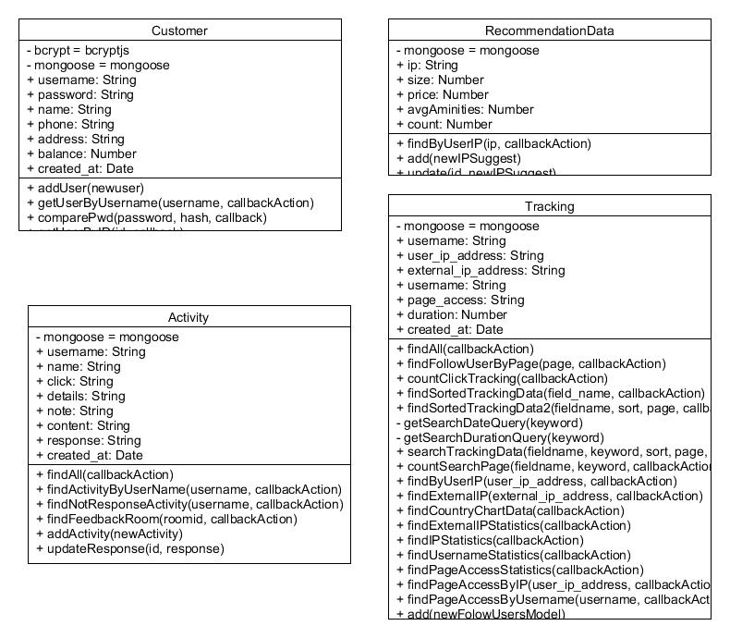

Figure 47: Express Model class diagram

These models communicate directly with MongoDB by mongoose library. They also provides datatype for Nodejs Application.

Model Customer contains customer personal information, username & password with some functions get a user by id, get a user by username, get list of users and edit a user.

Model Activity contains some activity of customer with some functions such as get an activity by id or a list of activities of an user by username, get the list of all activities, list activities that haven’t been responsed yet, list notifications to display for administrator, add new activity and delete an activity.

Model Tracking contains tracking data of user such as the IP address, the external IP, the page user clicked and the duration that user stays in this page with all functions to return the data of users tracked by the system, these data will be sorted, searched or filtered to provide other functions for reasonable purposes such as sort a list of tracking data by ip address, view tracking data by page, view statistics of page access and username or ipaddress, view country chart by location of user by ip address …

4.4.8/ Controller-JS

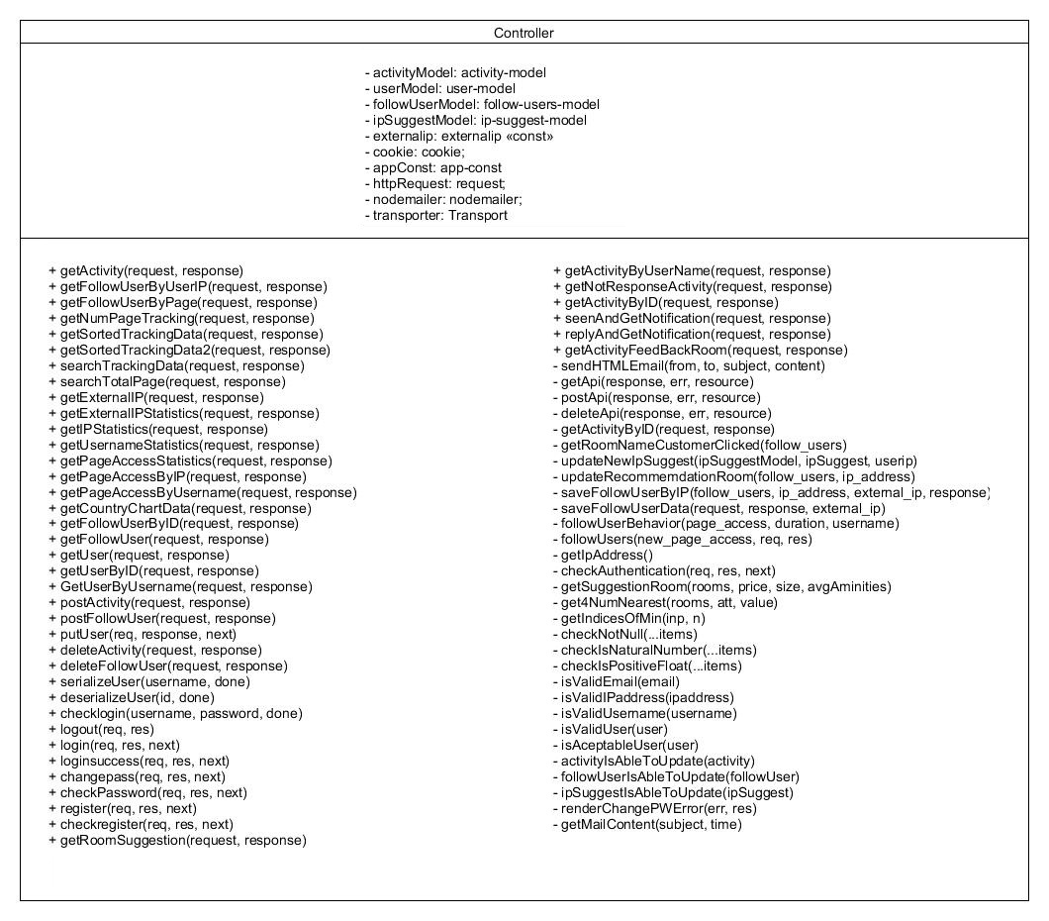

Figure 48: Express Controller class diagram

The Controller has a lot of checking function such as: check valid email, check valid ip address, check valid username, check user is acceptable, check activity is able to edit and so much more…

It also uses the Models as datatype and their functions that interact with MongoDB to create a lot of suitable functions for Routes.

4.4.9/ Route-JS

The routes are supported by Nodejs route library and Express framework which handle responses and requests of users from client side or from other apllications.

4.4.9.1/ AppRoute with EJS

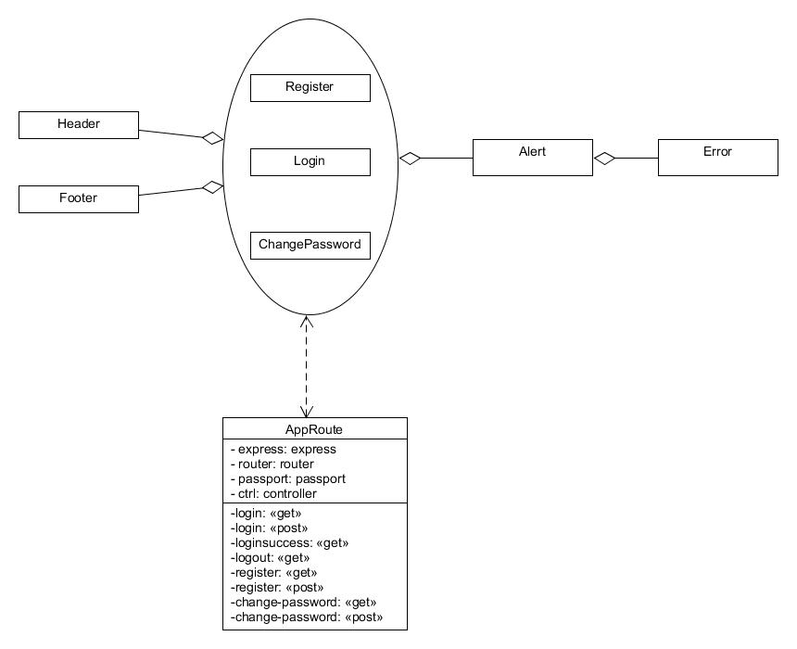

Figure 49: Express App Route and EJS class diagram

This AppRoute interacts directly with the EJS files to render the view. It supports function for login, logout, register or change password.

When users click on login, register or change password page, the load page requests will go to corresponding functions in AppRoute with request mapping is GET. The logic will be done by these functions and render directly the page that user requested.

When users input username, password or other information to login, register or change password. The requests will go to corresponding functions in AppRoute with request mapping is POST. Then the AppRoute will check the informations and return response display for users.

4.4.9.2/ APIRoute

Besides, there is no view render ed by APIRoutes, these Router’s mission is to provides a REST API for other application.

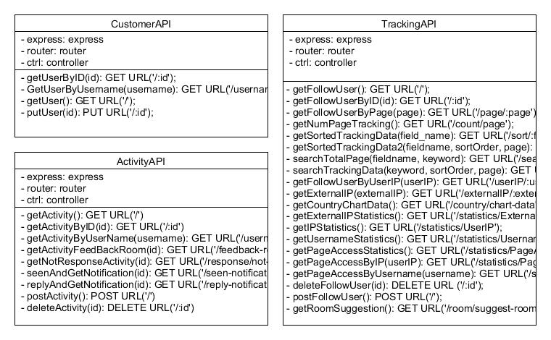

Figure 49: Express API Route class diagram

These RouteAPIs provides HTTP methods sych as GET, PUT, POST, DELETE. They are main components for building RESTful webservice by Nodejs and Express framework.

The CustomerAPI Route provides some methods which relates to Customer. Other application want to access the data from MongoDB need to ask this Route.

With ActivityAPI Route, all the activity of Customers can be retrieved or updated by another application without connect to MongoDB.

For which want to use the tracking features have to contact the Tracking API Route for data because it provides a huge amount of tracking data as JSON thought HTTP methods.

4.4.10/ Offical Express class diagram

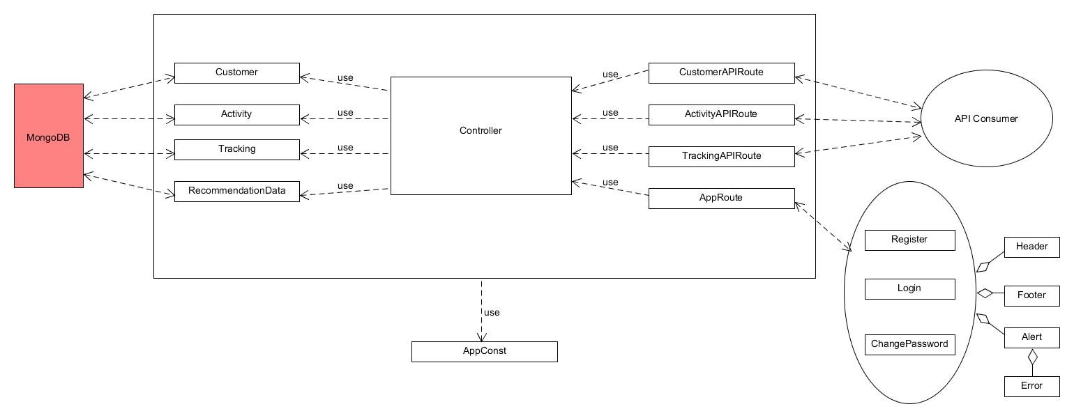

Figure 50: Offical Express class diagram

This is general Nodejs Express framework class diagram. As you can see the Model includes Customer, Activity, Tracking and RecomendationData interact directly to MongoDB then provides functions and data for Controller exceutes bussiness logic. The finall step is from the AppRoute to view or from CustomerAPI, ActivityAPI and TrackingAPI Routes to build RESTful APIs provide data for other application. The AppConst is used as the CONST data storage where contains all the neccessay constant variables.

***4.5/ Implementation***

Arcoding to the class diagrams above, I will debcribse in bref how I implemented the some mandatory features that every hotel booking system supports and several highlight features of my system.

Firstly, let’s focus on the feature related to collections in MongoDB.

4.5.1/ Customer feature

As you knew, customer needs an account to login into system to book room, send feedback, view profile with transaction history. The login process first checks whether user have logged in or not by passport library of Node.js. If they have signed into system successfully, the system allow to use these features. When customers logout, the session and cookie are remove so that they cannot use customer’s features anymore.

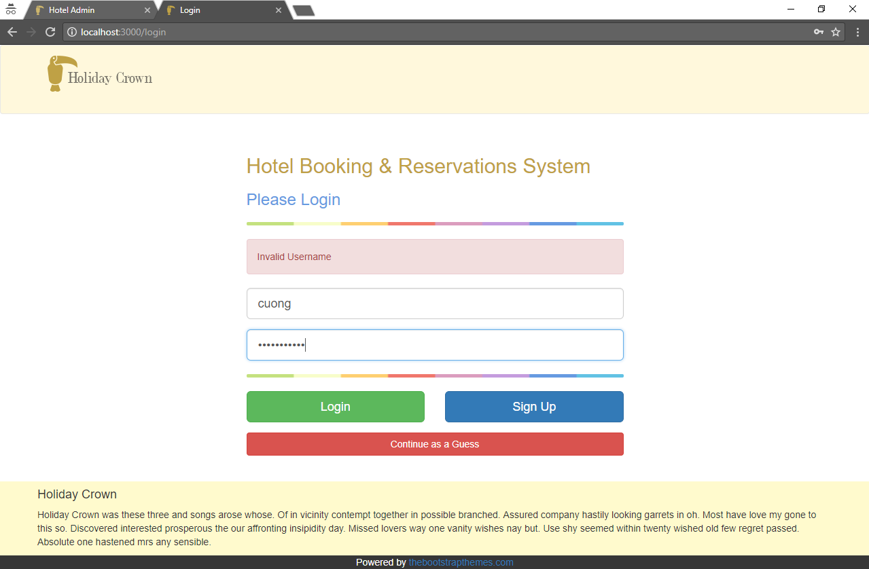

Figure 51: Customer login feature

The register feature is actually the function that add new user into customer collection of mongodb. The password must be encrype by bcryptjs before the customer data are inserted into database collection. This function also works for change password feature which compare the hash encrype password with new password and confirm password; if new password is different from current password and the confirm password is correct, the system will update the password of customer to mongodb.

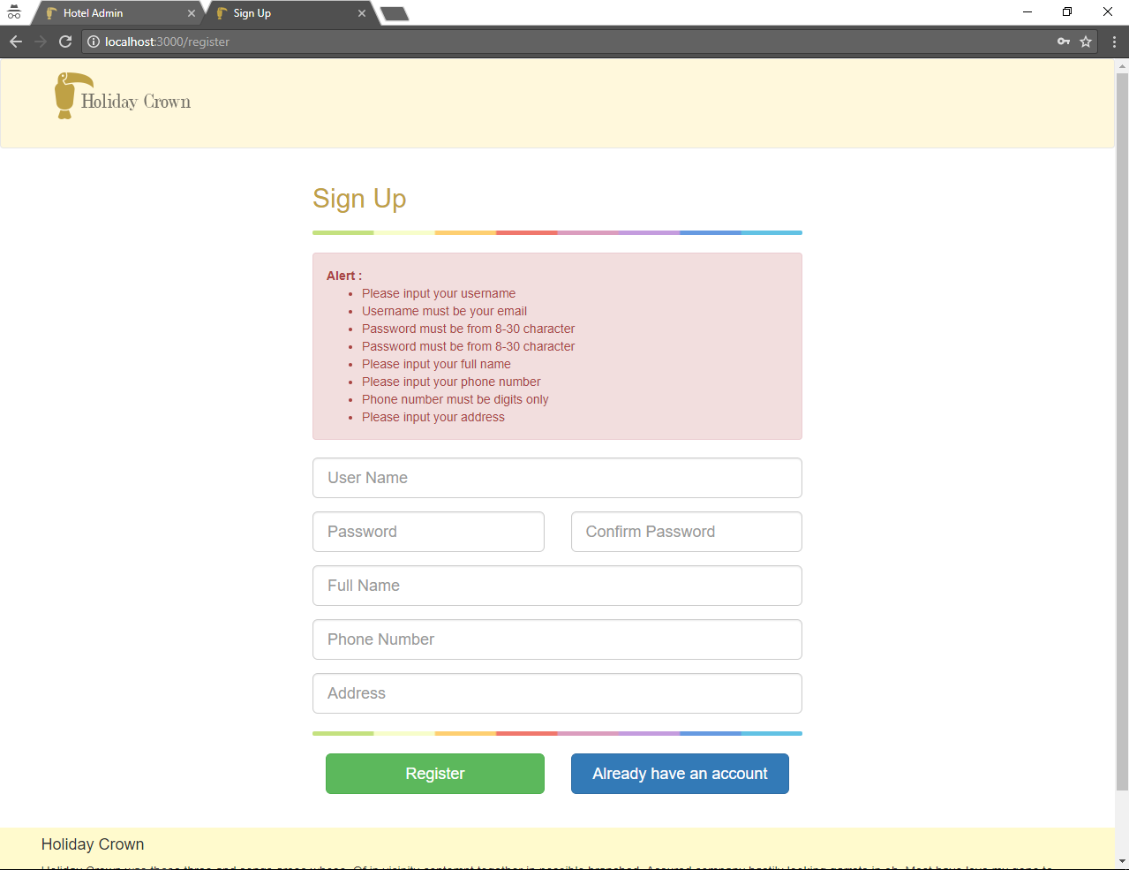

Figure 52: Customer register feature

With EJS powered by Express framework and Nodejs, all the input data of customer to register, login, change password are validated by request.checkBody function.

Nodejs & Express RESTful webservice is the transportation connect to Mongodb for providing Customer data as JSON though API. Every feature relates to customer have to contact with this webservice for retrieving data or update to mongodb.

For example, to manage Customer, the CustomerDAO has to get the customer information from REST API to display for Administrator

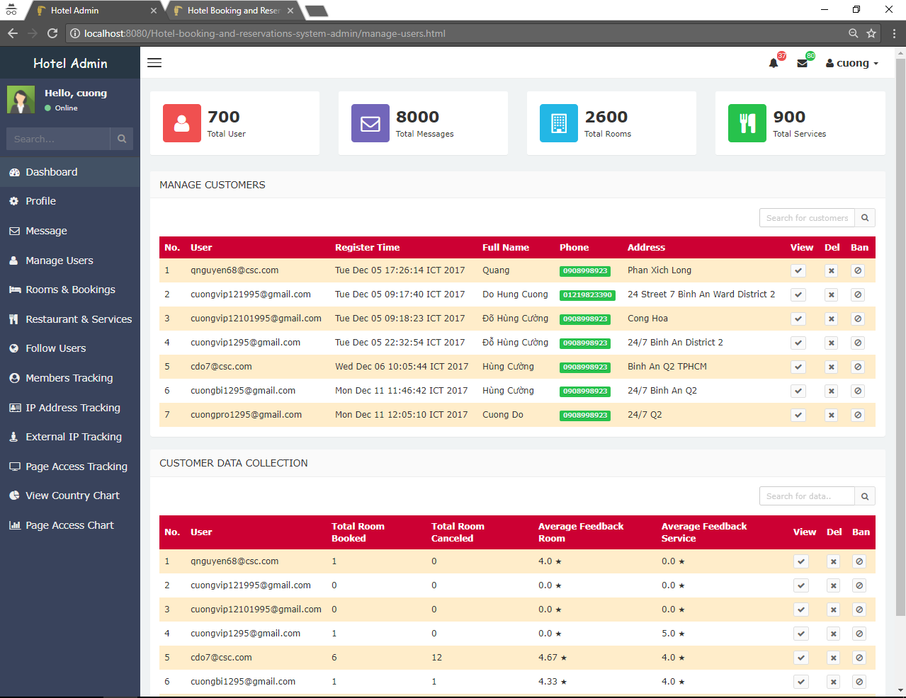

Figure 53: Manage Customer feature

4.5.2/ Activity feature

All activities of customers are stored in activity collection. Whenever a customer books a room, cancels a room, sends feedback, rates a room, sends contact or sends reservation form, Angular 2 send request with parameters (if necessary) by HTTP POST method to Node.js for checking these parameters whether they are acceptable or not. If all the paramaters are valid, Nodejs then insert new activity into MongoDB.

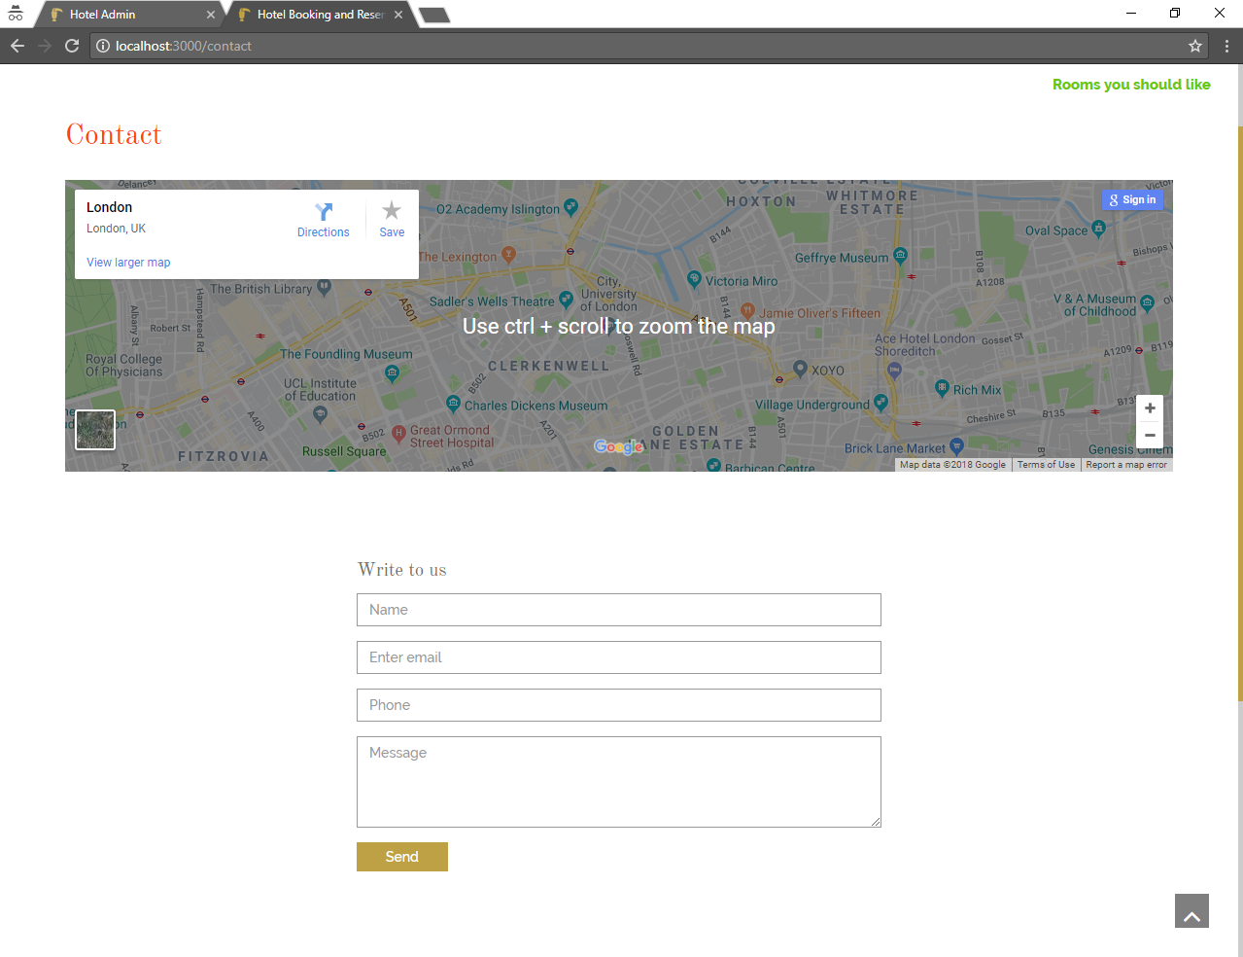

Figure 54: Send Contact Feature

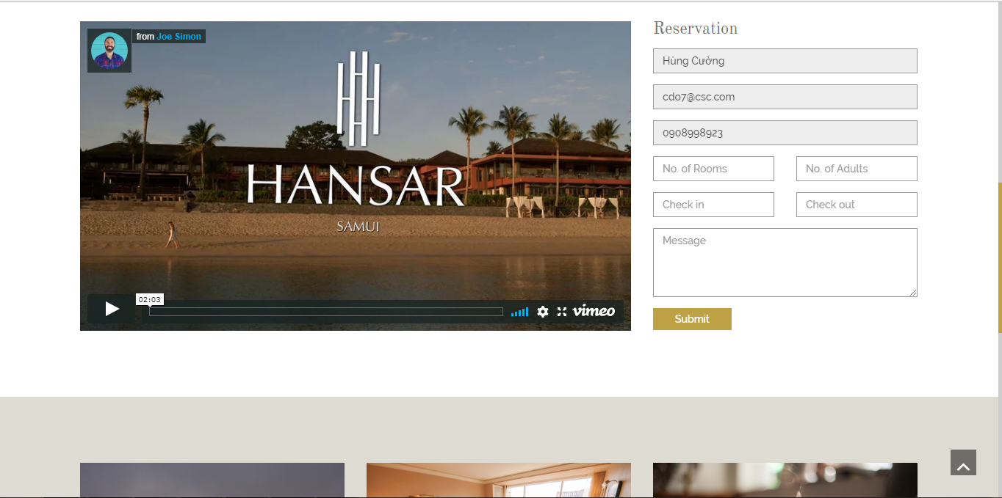

Figure 55: Send Reservation Form feature

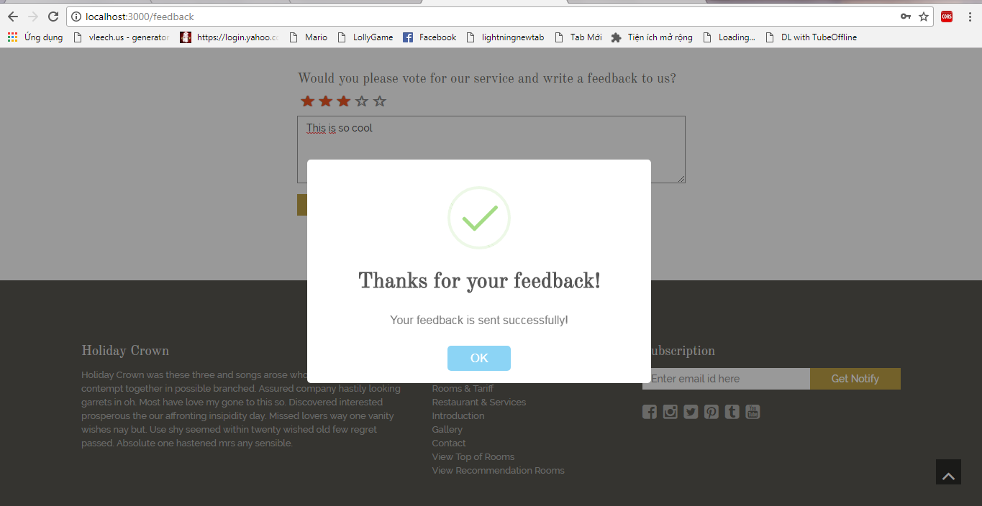

Figure 56: Send Feedback feature

Customer can review his activity which is shown like a transaction history.

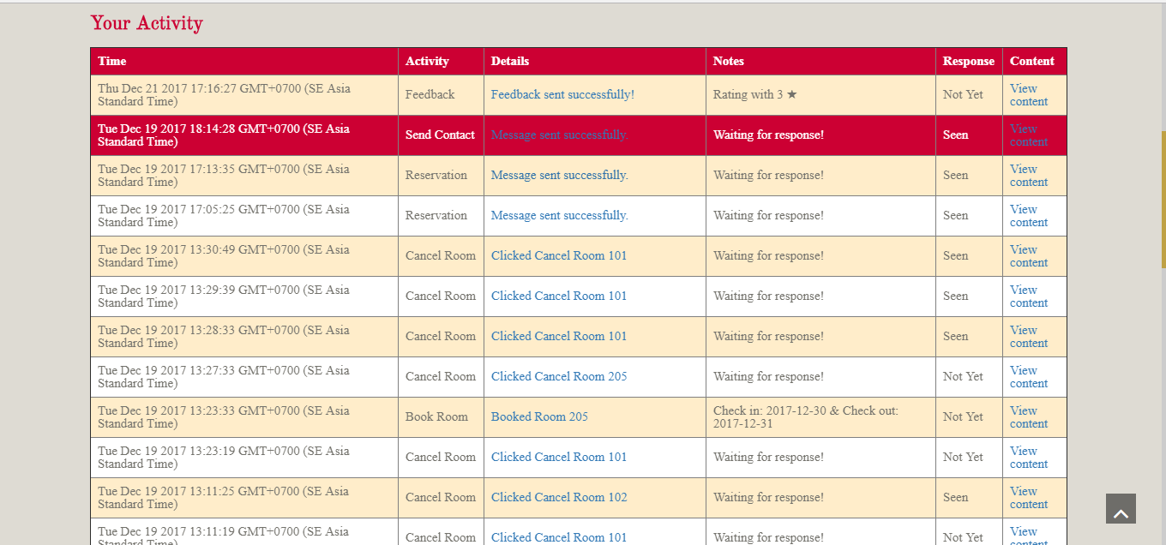

Figure 57: Review Activity feature

These activities will also be managed by Administrator. When admin needs to access the activity collection, the system has to interact with Node.js RESTful API to return activity data for Admin to view as well as update the response status of Adminsitrator when the notification or message about this activity is reply.

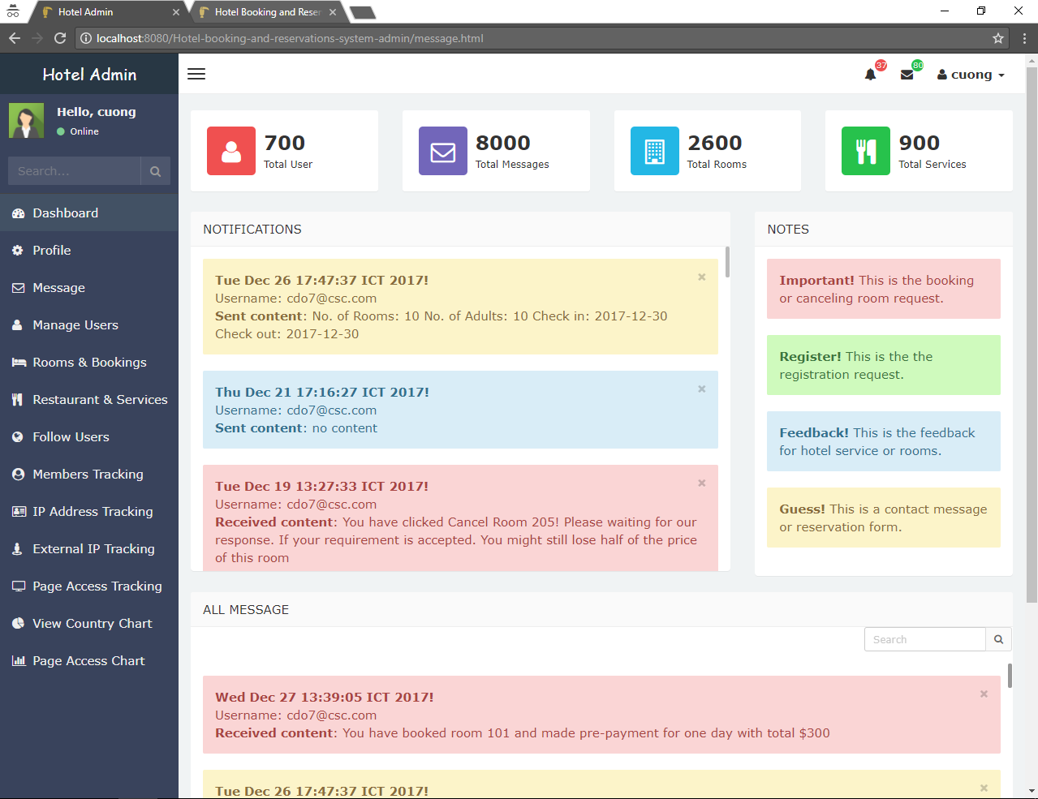

Figure 58: Manage Customer’s Activity feature

Besides, when Customer excutes an activity, an email is sent to his mail box using nodemailer library and adminsitrator is able to reply the email using javax.mail library with some availabe email template that analysed simply based on information of each activity.

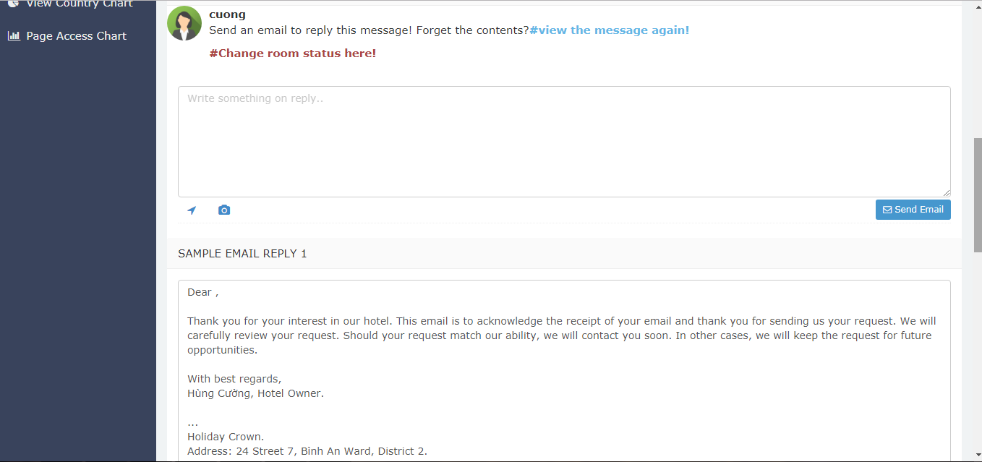

Figure 59: Reply Email feature

These activity and customer data can be use to calculate the customer data collection includes list of rooms booked, rooms canceled, rooms feedback and rating scores with comment, the average rating score and all personal information of customers which will be displayed for administrator.

4.5.3/ Tracking User feature

For track users features, The system first find the Ip address and external ip of the user by external-ip library for nodejs. Whenever users click on a page, search for item, login, logout or do anything on the website, all actions of users are tracked on client side with Angular 2 and requests are sent to Nodejs RESTful API to compute the duration that user stay on each page. The formular to calculate the duration is that the previous action information is stored by cookie with the time user click on each page, then when the next action occurs, the system will return the duration that equals to the subtraction of time in millisecond of the current page access and one of previous page access. All tracking information are stored in tracking collection of MongoDB.

The user is tracked who is automatically assigned the wished data for room recommendation by the system. Everytime user does whatever actions relate to a room such as click room, click image of room, search room, view room’s details, book room … The system will update the user’s recommendation data include average size of room usually interact, average price, average amenity to Mongodb. Then when user accesses recommendation rooms page. the Controller then calculates the list of rooms with the best fit with user’s recommendation data that means the list of rooms have the closest data compare to the size, price and amentiy that customer usually interact. After returned the final result, Angular 2 will get it by HTTP Method from REST API provides by Node.js API Route to suggest room for User.

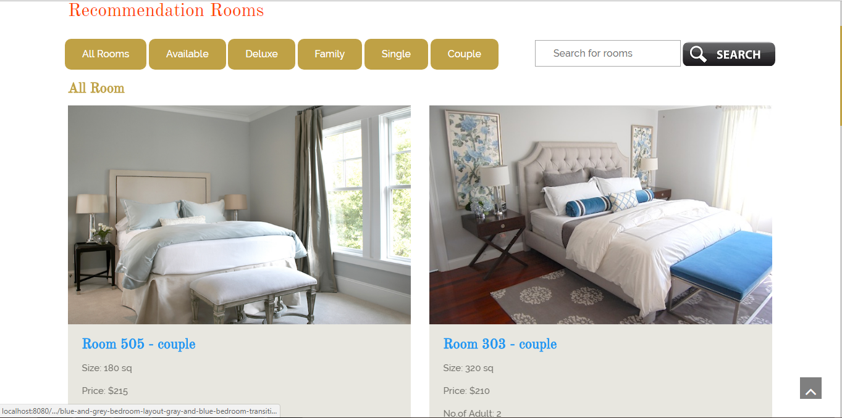

Figure 60: Rcomemdation Room feature

With the tracked data above, Aministrator can view tracking information by AngularJS which communicate with the Node.js REST API for retrieving data. On this feature’s user interface web page, Administrator can view all data at the same time or filter by page, sort data in each field by alphabet, by number or by duration time or search for desired information. These filters will be provides by AngularJS which interact with Node.JS API to retreive data from MongoDB.

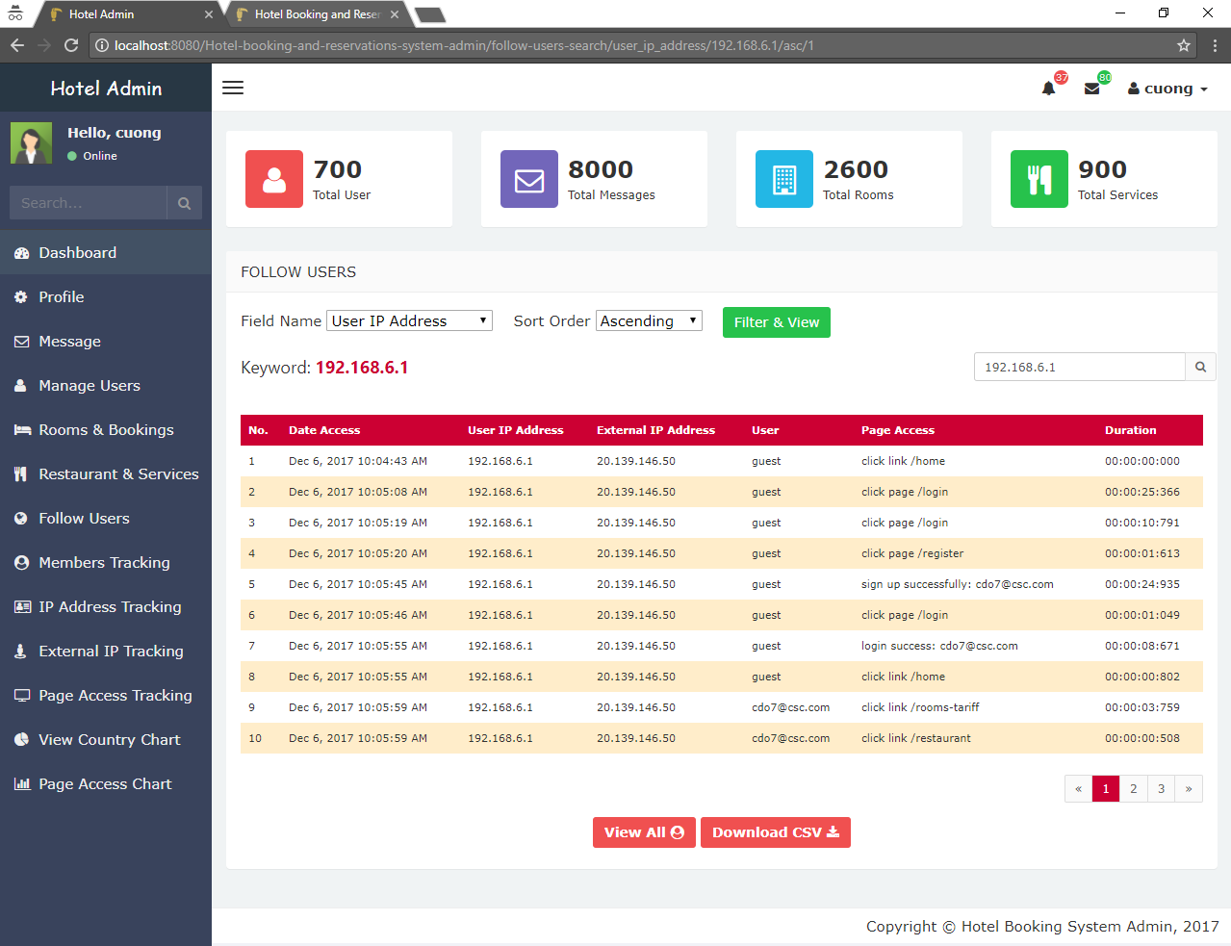

Figure 61: View tracking data feature

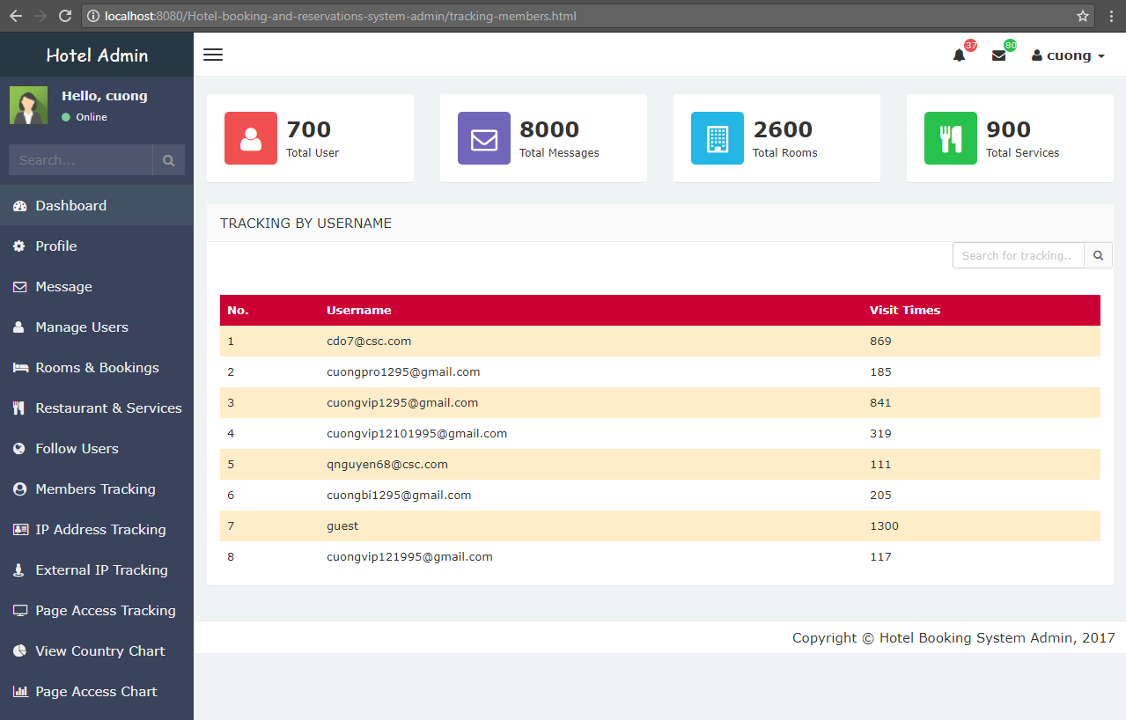

Figure 62: View tracking data feature by username

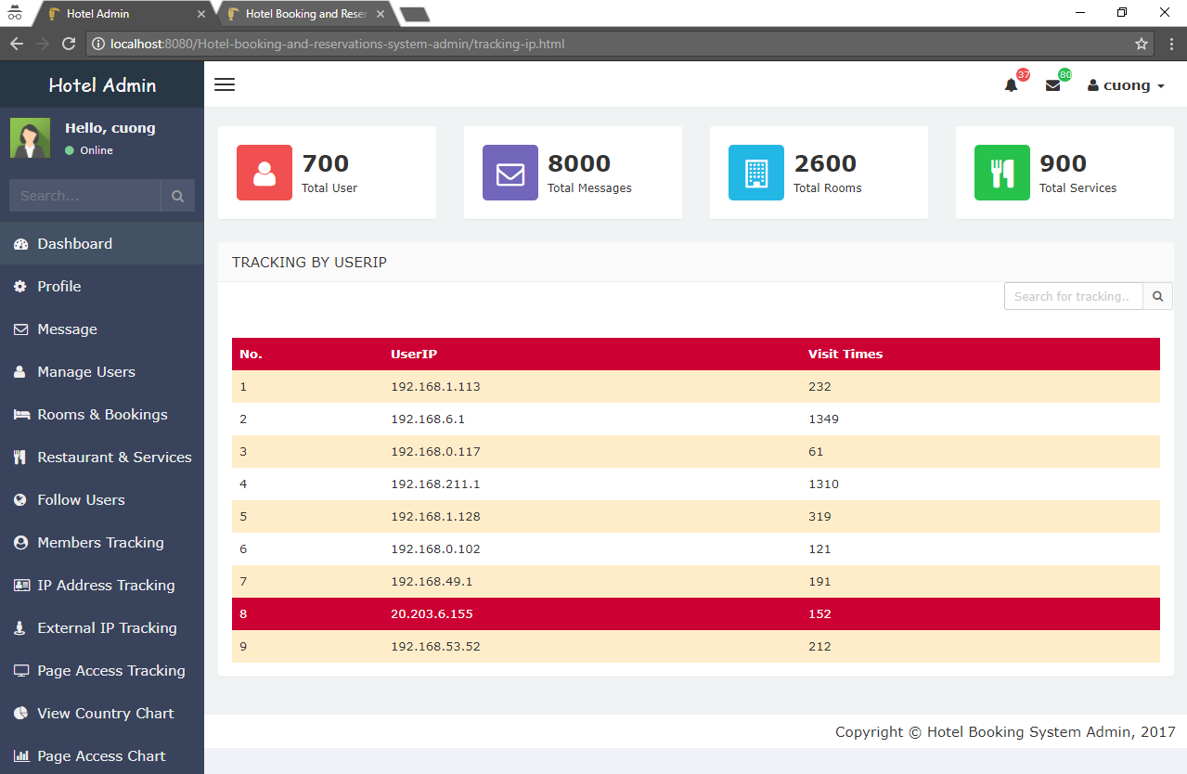

Figure 63: View tracking data feature by ip address

Furthermore, with geoip-api library, Administrator can view location of user with some addition information look up from the ip address of the user.

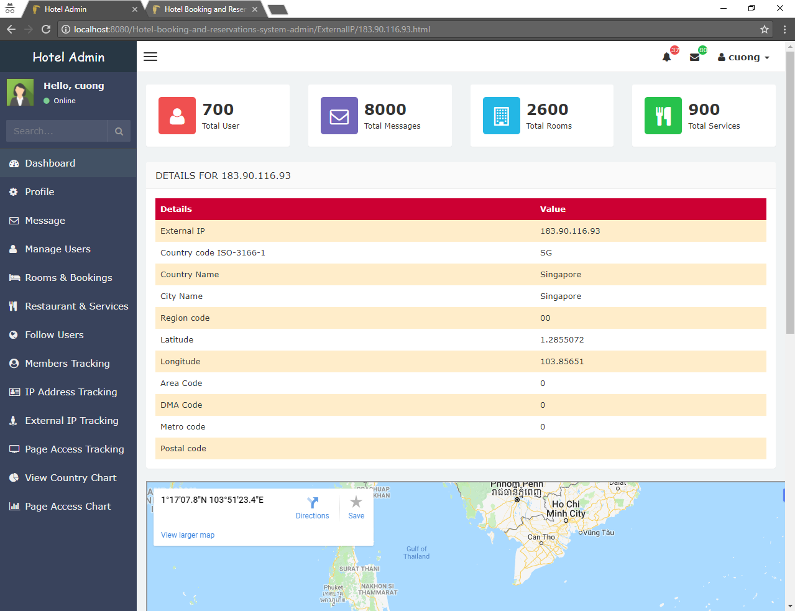

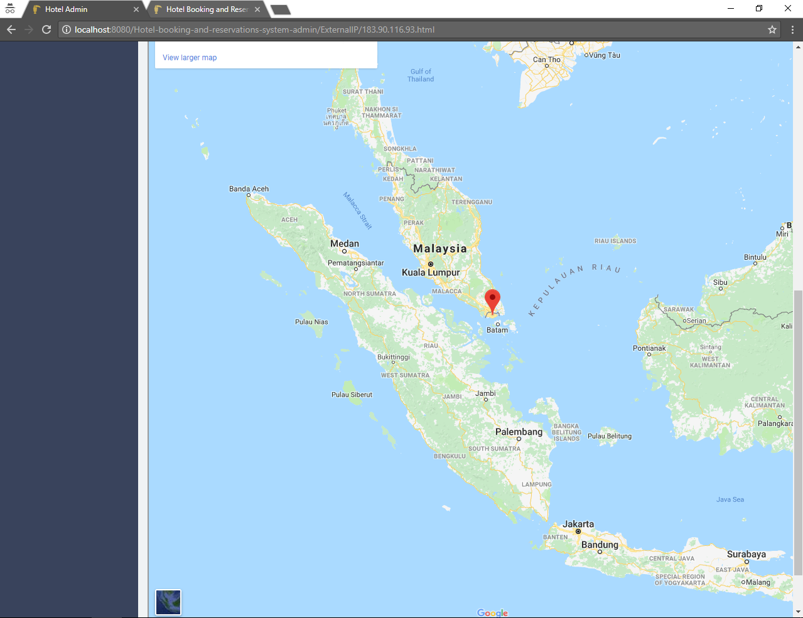

Figure 64-65: Geo Location Lockup Feature

The tracking data can be used to draw chart.

Using AimChart Javascript library with AngularJS, the system is able to show the pie chart of country and colunm chart of Tracking Data by username, user ip and page acess. This AimChart library also support feature that allow to export or download chart image as JPG, PDF, CSV …

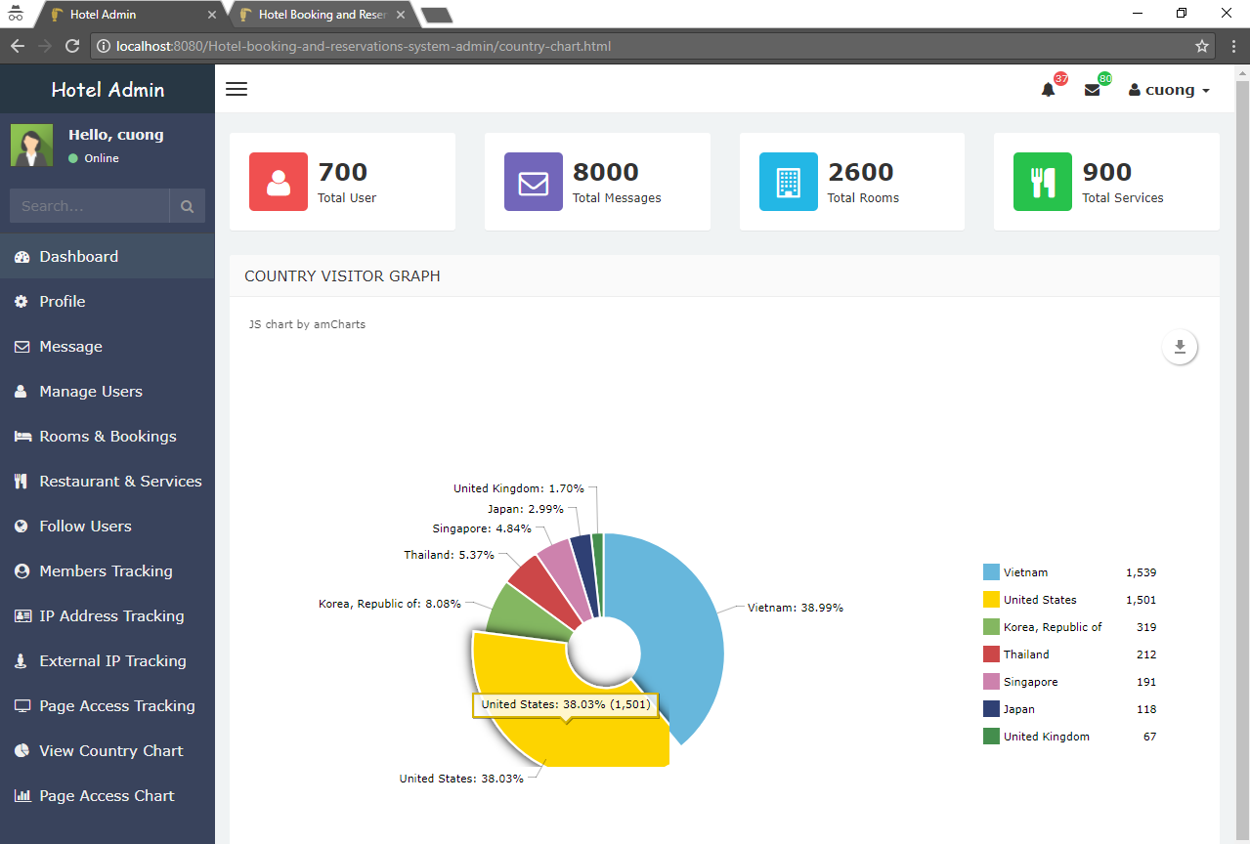

Figure 66: View Pie chart by Country and visit time Feature

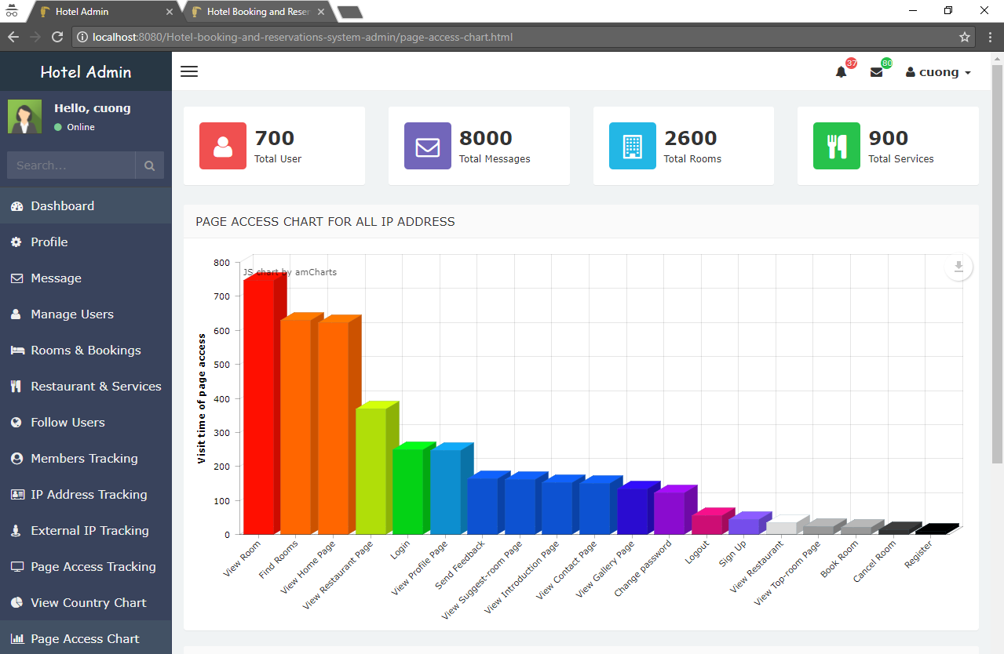

Figure 67: View Colunm chart by Page Access and visit time Feature

4.5.4/ Room feature

Secondly, for SQL database system, We have a lot of features related to room, restaurant and Adminstrator. The features for room and restaurant are quiet similar but there are more features for room than restaurant.

The adminsitrator can create new room by input information of room such as name, type, size, number of adults, amenities, details then they will become parameters and be sent to Spring AppController which uses method add new room from RoomService. Then, RoomService call methods from DAO user HotelRoom Model to check whether input data is acceptable or not. If input correctly, Hibernate framework will create new seassion factory to insert into room table of SQL database system.

This process is similar for some features includes edit room, delete room, add new restaurant item, edit restaurant item or delete restaurant item.

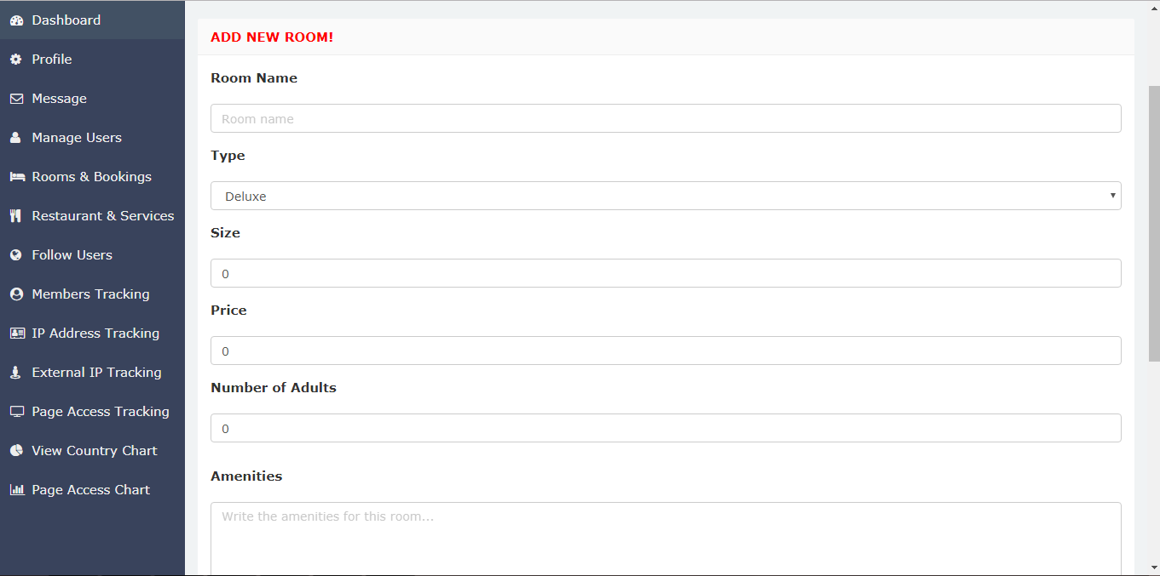

Figure 68: Add new Room Feature

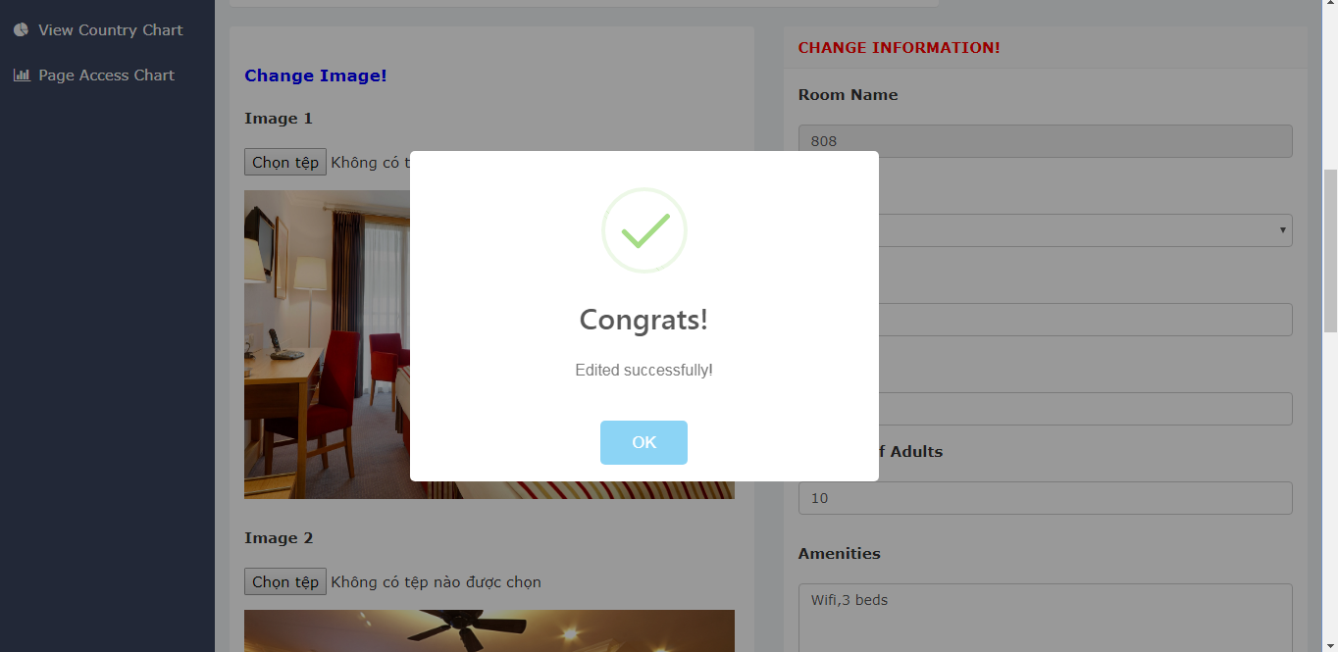

Figure 69: Update Room Feature

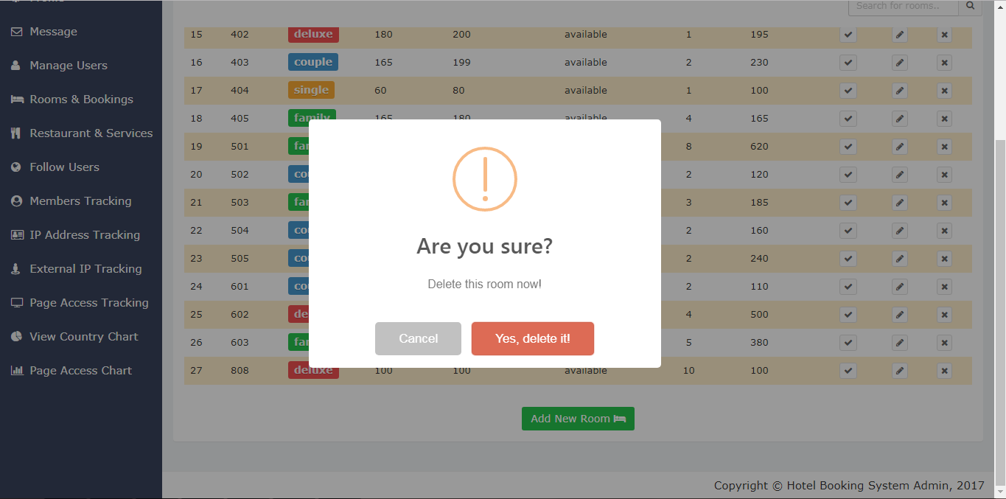

Figure 70: Remove Room Feature

Moreover, adminstrator can view this list of rooms, view a single room with all more details and informations, search or sort the room by keyword or by its attributes. These search and sort functions are written in jQuery that need the list of rooms which was retreived from SQL through Hibernate, DAO and HotelRoom Model. The process is the same for Restaurant Item.

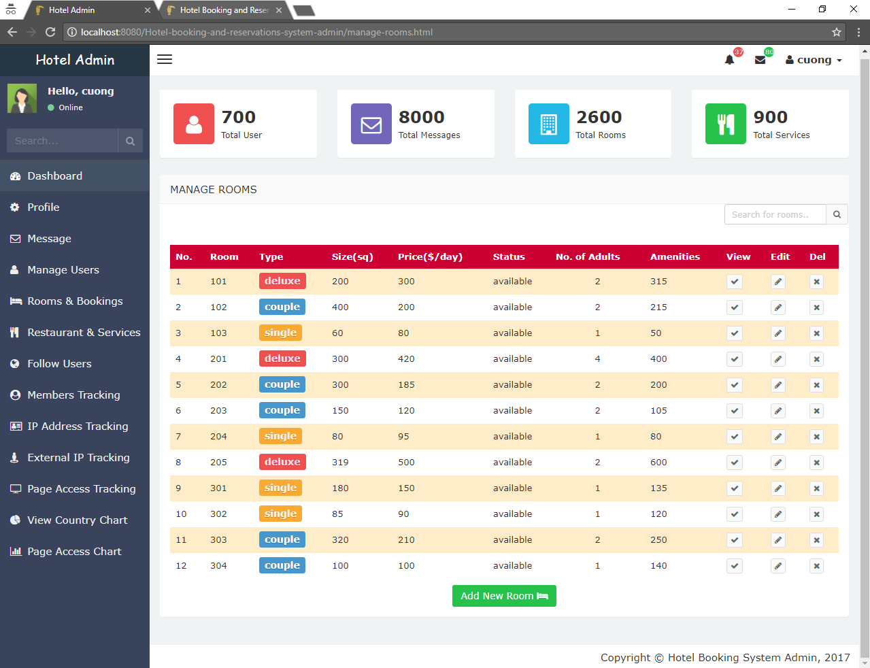

Figure 71: View All Rooms Feature

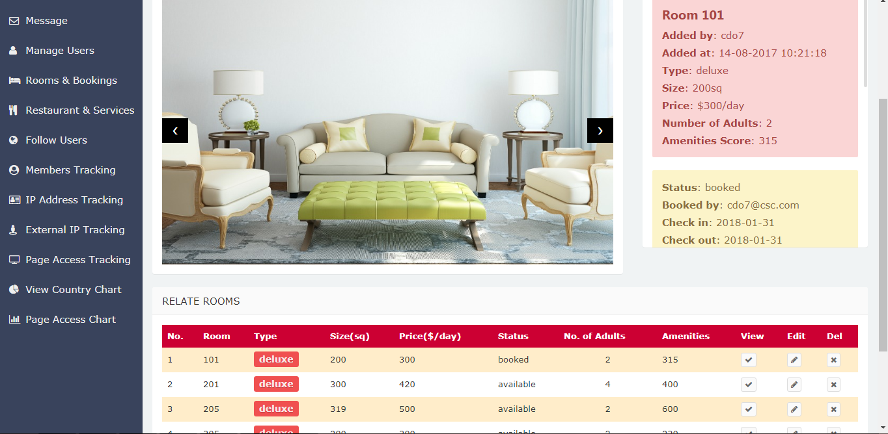

Figure 72: View Single Room with Related Room Feature

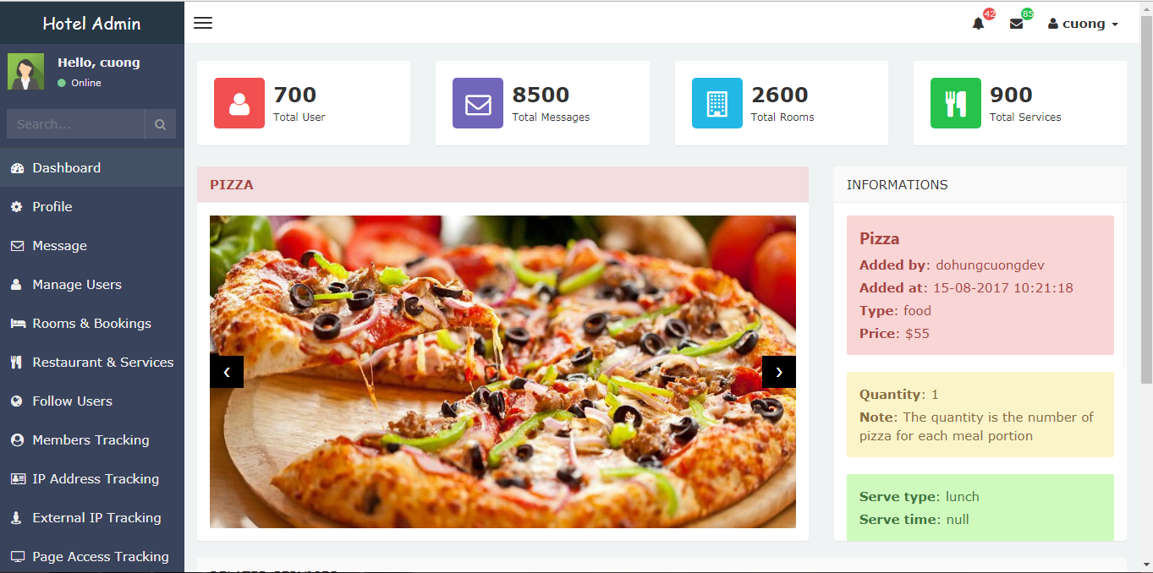

Figure 73: View Single Restaurant Item Feature

Besides, the customer cans view the room and restaurant item on client side with Angular 2 which get data by HTTP method from Spring RESTful webservice where stored data as JSON. The data is retreived like the process in section above but return data to REST Controller instead of AppController.

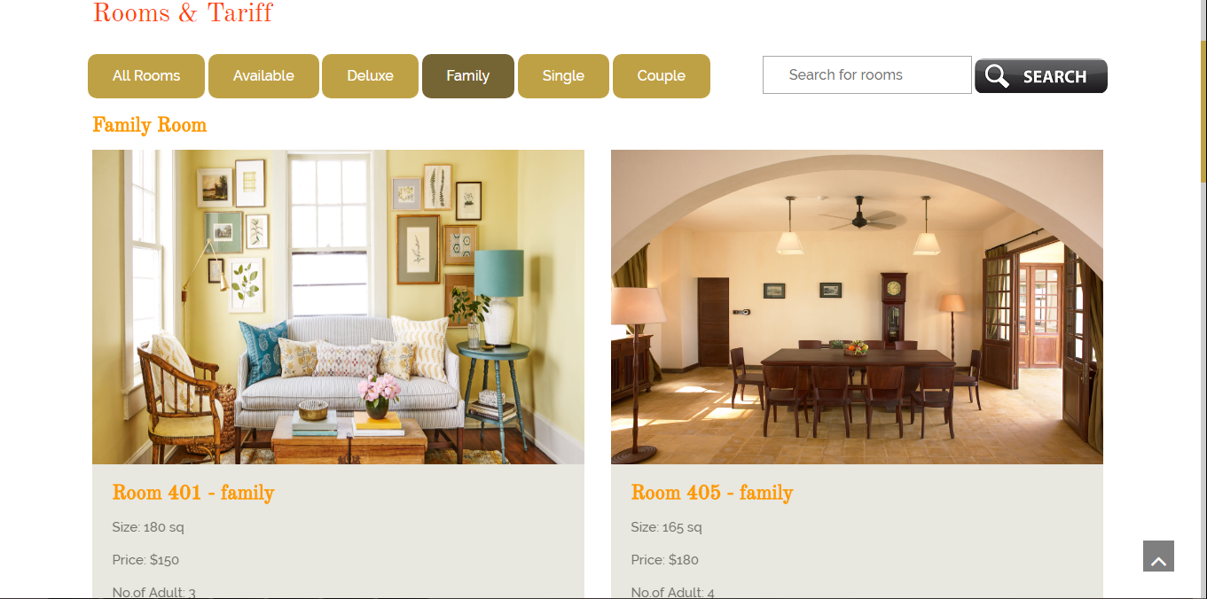

Figure 74: Customer view Rooms

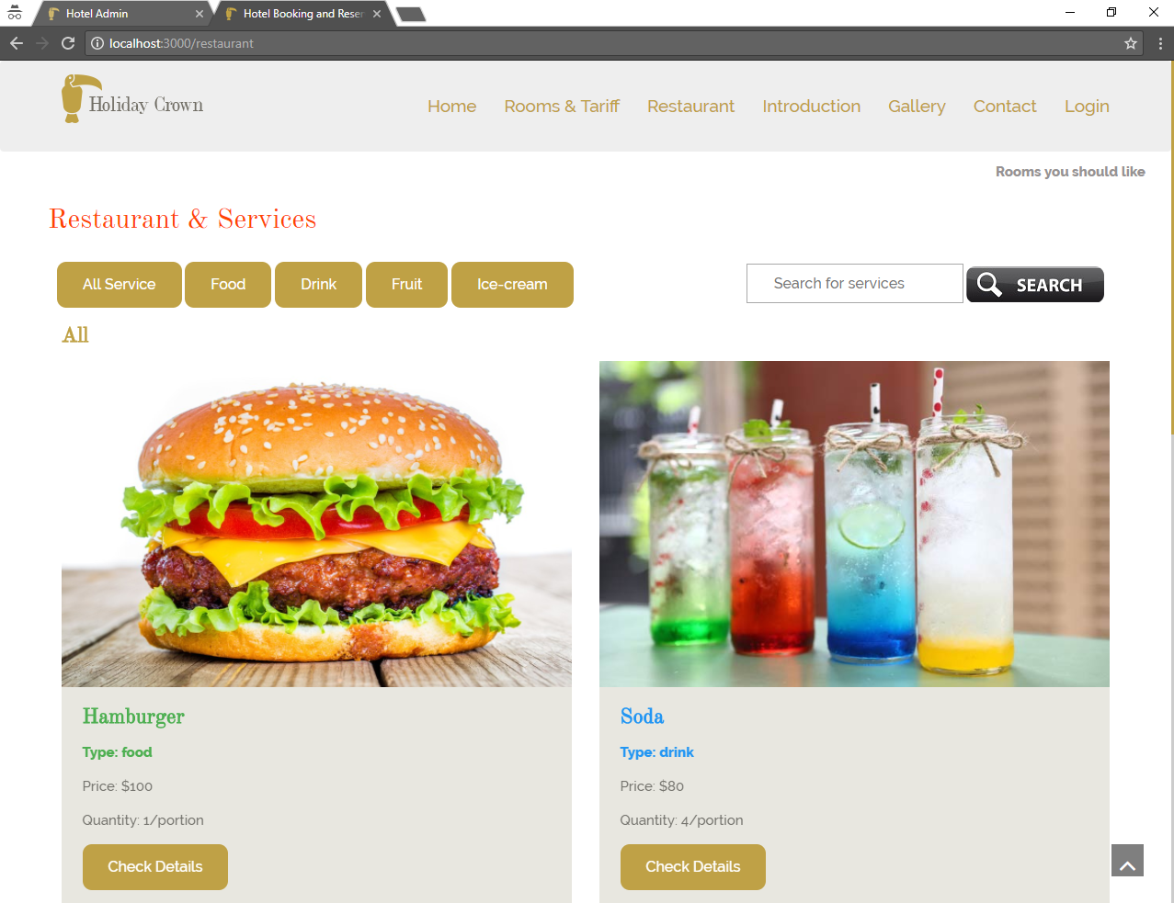

Figure 75: Customer view Hotel Restaurant

Customer can book room, cancel room or send feedback for a room. Of course when they request for this activity, the process update activity will start ( see more in section 4.5.2). In addition, because these activity relate to room so they need to request Spring RESTful webservice for retreiving data or update.

If customer books a room, the request is send to Spring REST API and computation is excuted. If the account balance is enough to pay for this room. REST API will update the status of the room and subtract the account balance of the user. If not enough money, system will response message to notify the customer.

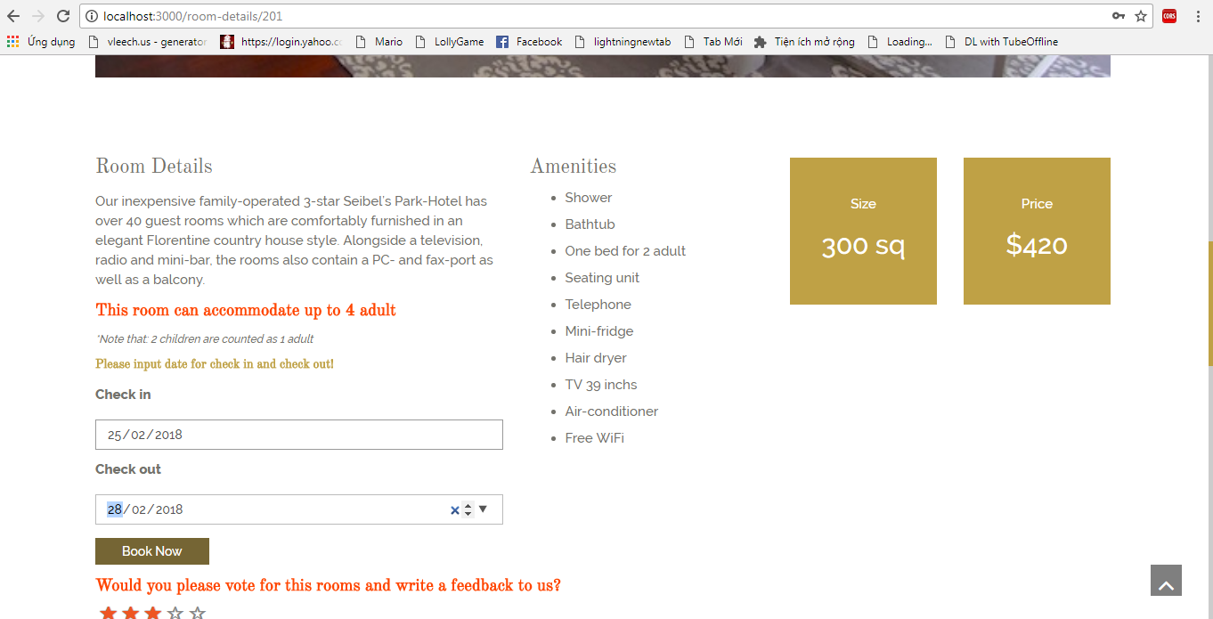

Figure 76: Customer book room feature

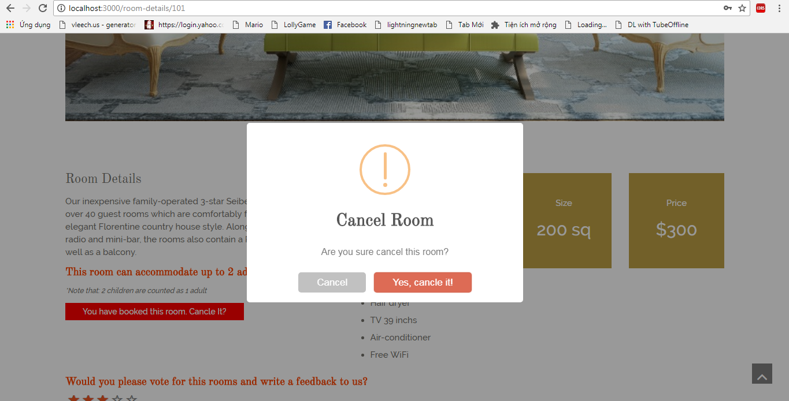

Figure 77: Customer cancel room feature

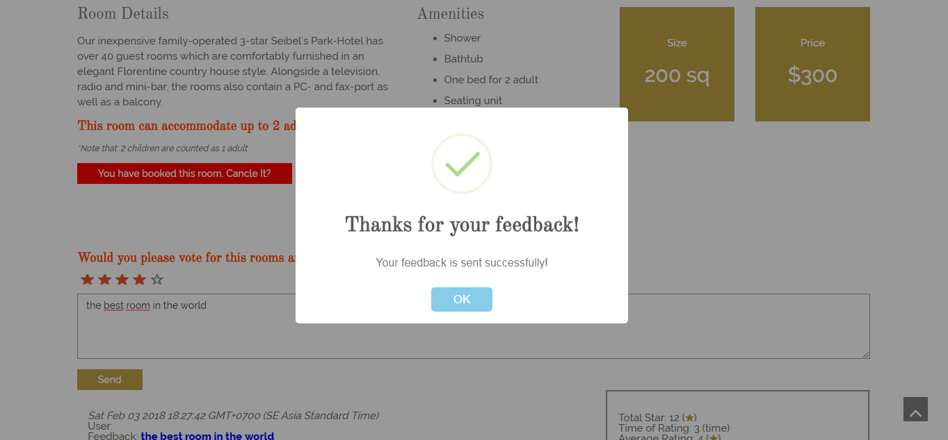

Figure 78: Customer feedback room feature

4.5.5/ Admin feature

In my Spring MVC server, the Admin features have no relationship with other application. That means all the features just follow traditional MVC pattern.

After login, Spring framework saved the administrator data as by session, until he logout

Admin can also change password, change personal information, update avatar in profile page.

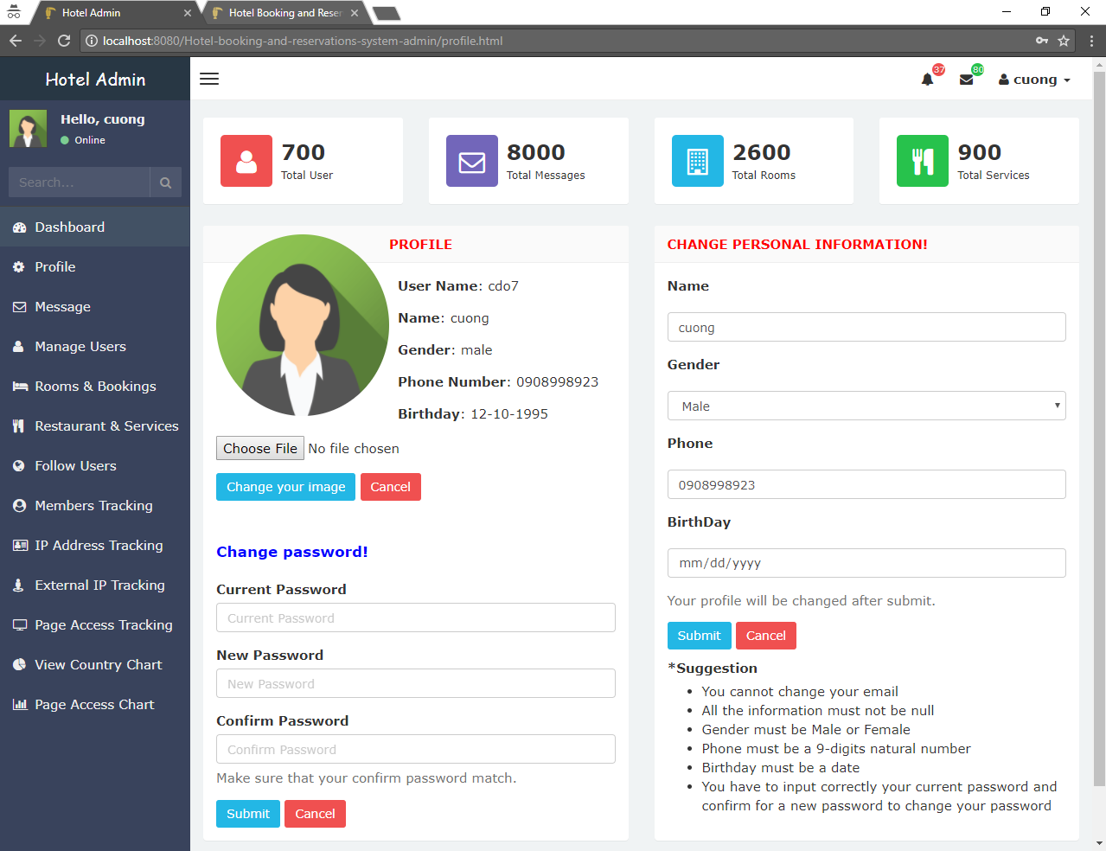

Figure 79: Admin profile feature

4.5.6/ Other highlight feature

To easily manage the system, Administrator need a seach feature. This feature helps administrator to input a keyword and search for a lot of things includes message, notification, users, rooms, restaurant items…

This feature is built primarily by jQuery with data retrieved from SQL by Hibernate using 4 models Activity, Customer, HotelRoom, HotelService with their corresponding DAO and Service.

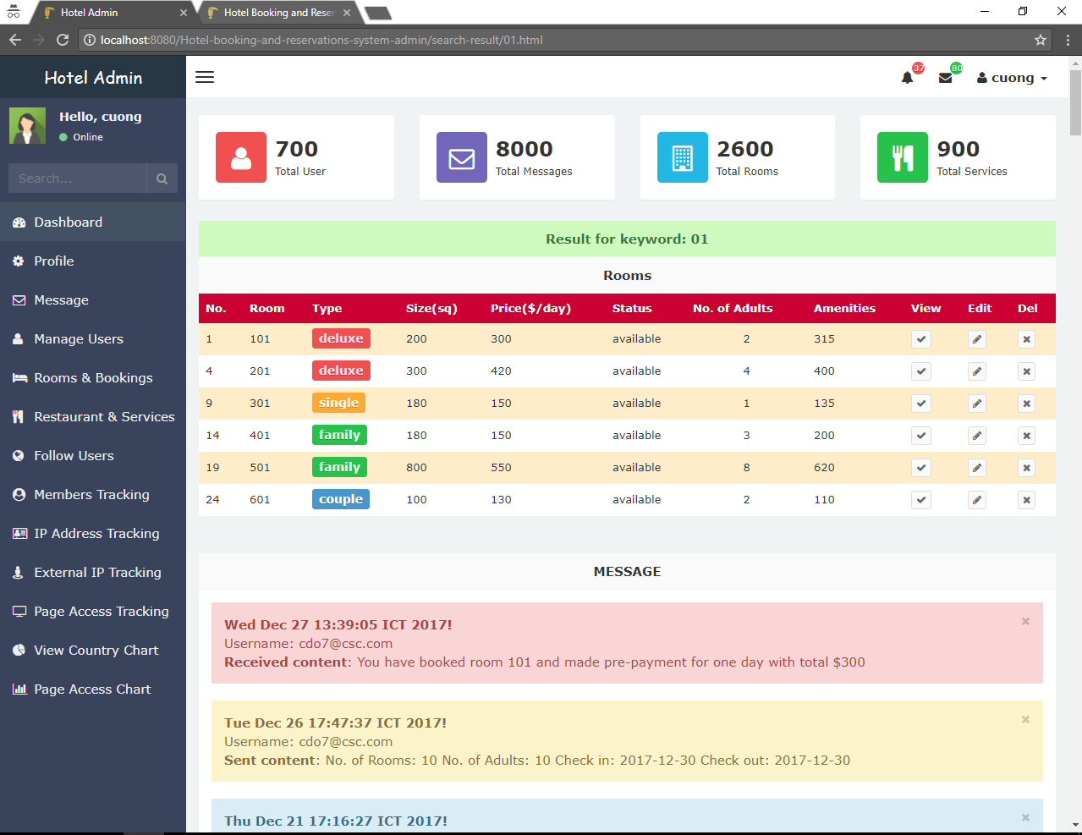

Figure 80: Advance search feature

**Chapter V.** **Experiment and Evaluation**

***5.1/ Experiments***

These image below will prove that my system has friendly user interface and work well on many browsers such as IE, CocCoc, Chorme, Firefox, Microsoft Edge. Moreover, it also run well on many mobile phone operation system such as android, nokia, ipad. Laptop, desktop

Run Adminsitrator’s page on desktop with Firefox

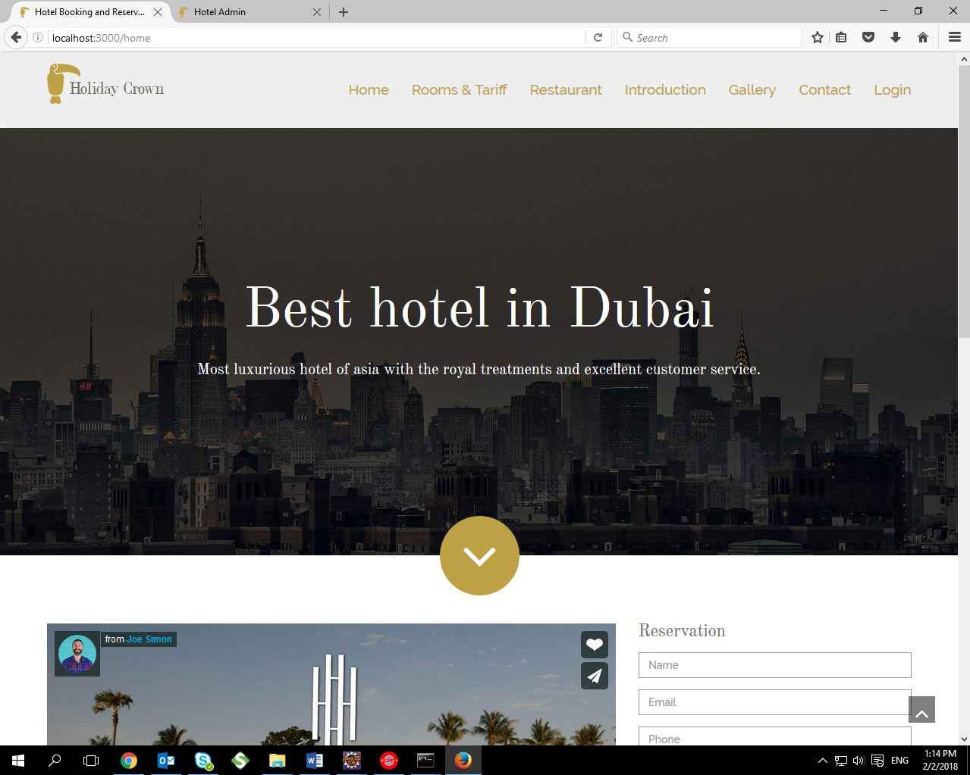

Figure 81: Experiment on Firefox

Run Adminsitrator’s page on desktop with Microsoft Edge

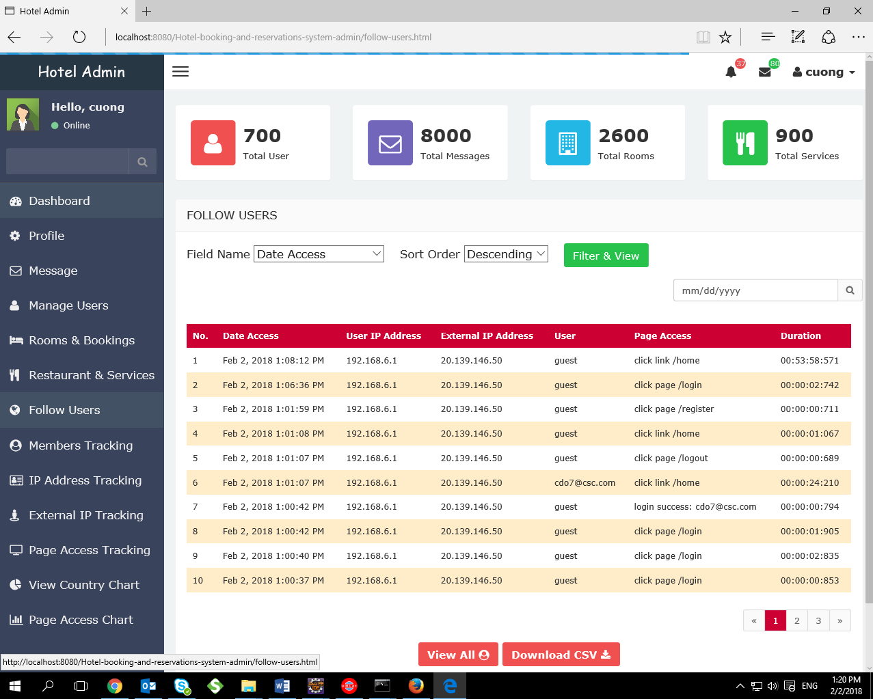

Figure 82: Experiment on Microsoft Edge

Run Adminsitrator’s page on desktop with Internet Explorer

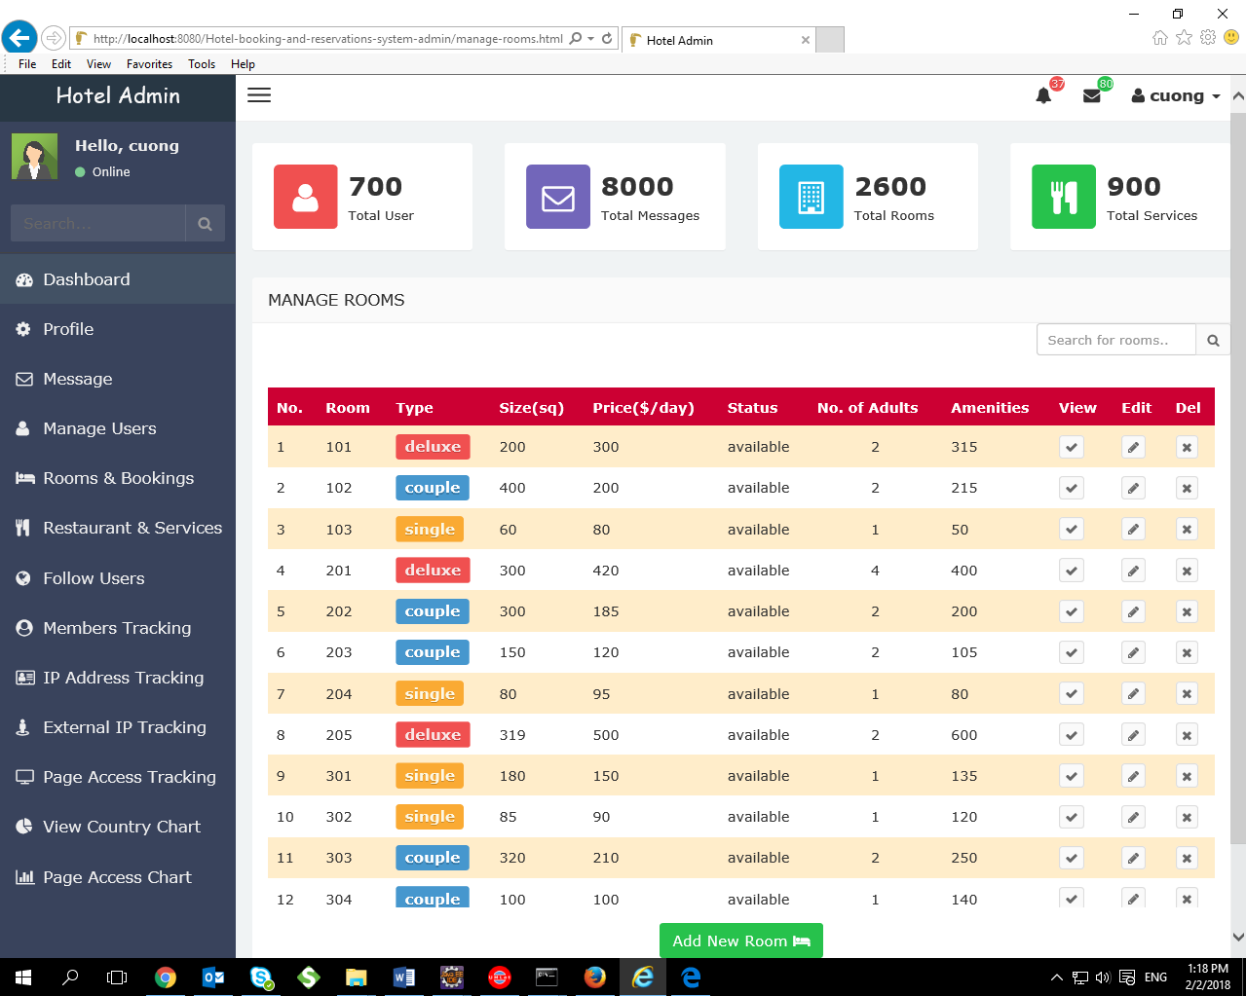

Figure 83: Experiment on Internet Explorer

Run Adminsitrator’s page on laptop with Chome

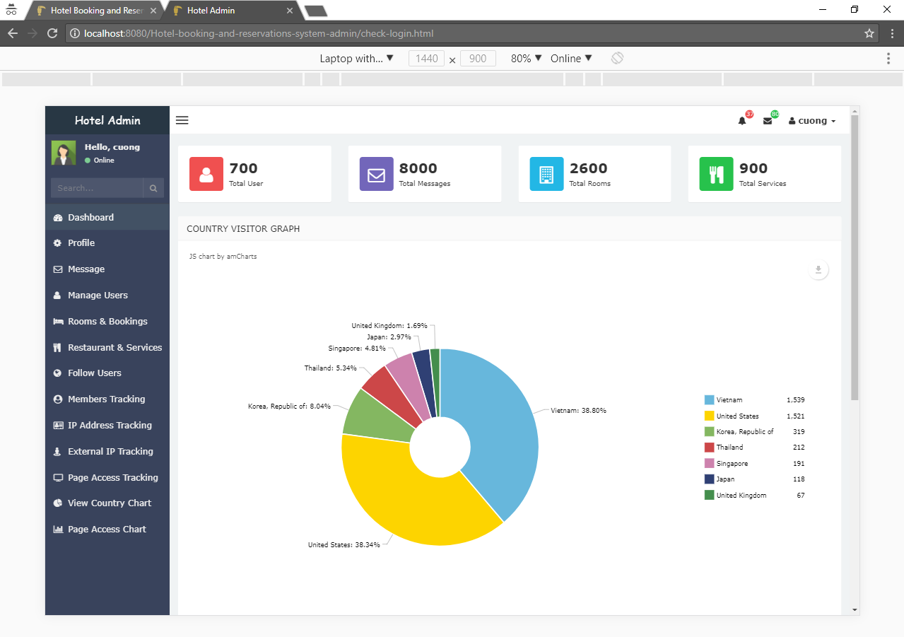

Figure 84: Experiment on laptop with Chome

Running Customer’s page on mobile (Iphone 8 plus)

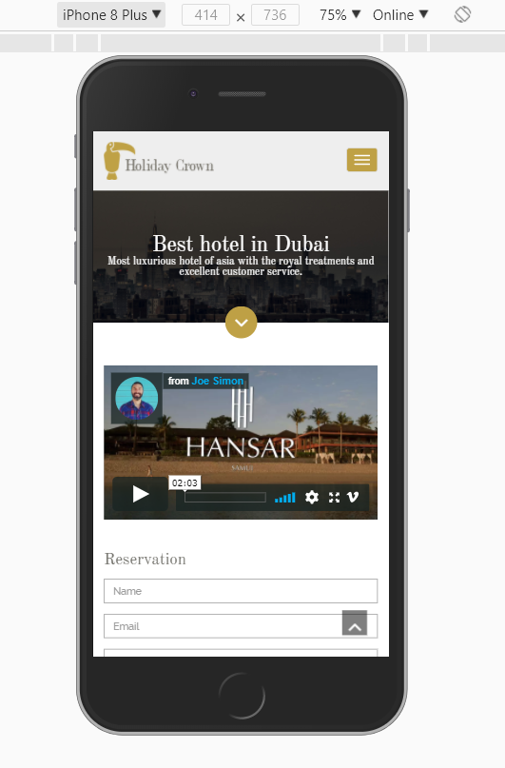

Figure 85: Experiment on Iphone 8 plus

Running Customer’s page on Ipad

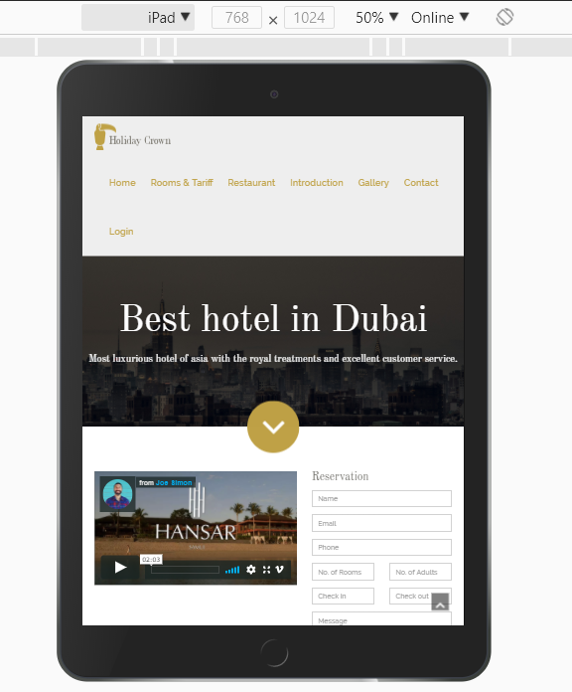

Figure 86: Experiment on Iphone 8 iPad

***5.2/ Evaluation***

Arcoding to experiment and all the sections above, tt proves that my system is an online single page web application with high performance and dynamically loading. It also has friendly user interface which supports running on many browsers, devices include smart phone, ipad, laptop and desktop. Moreover, it owns almost features for hotel bookings & reservations management; it has ability to track user’s behavior and automatically recommend rooms for customer.

**Chapter VI.** **Conclusion**

Hotel business is a highly profitable industry but requires huge investment as well as having to meet the customer's demand. However, managing the hotels is not easy, Therefore, hotel management system is really important. The key of hotel business is service which means pleasure the customers. The best management system will bring the highest profit but there are many factors and difficulty to build a good management system.

After applied MEAN stack and Spring MVC to implements Hotel Booking system, I recognize that my system has friendly user interface, high performance with dynamically loading. Moreover, with tracking customer’s behavior feature, you can easily know what customers like and what they don’t in order to improve system day by day to match with customers ‘s wish.

In the future, I will add more features, apply machine learning with enough data collection

After thesis, I have learnt a lot of new things, I learnt a lot of technologies such as AngularJS, Angular 2, MongoDB, Spring MVC, Nodejs, Express Framework. I can work with a lot of frameworks and I have ability to learn new technology. I also had a lot of experience in building single page application. I will improve myself in the future for working in professional environment

**Chapter VII. Reference**

<https://docs.spring.io/spring/docs/3.2.x/spring-framework-reference/html/mvc.html>

<http://terasolunaorg.github.io/guideline/1.0.1.RELEASE/en/Overview/SpringMVCOverview.html>

<http://viralpatel.net/blogs/spring3-mvc-hibernate-maven-tutorial-eclipse-example/>